https://vi.scribd.com/doc/213568328/29/KILN-OUTLET-SEAL

A PROJECT REPORT ON
STUDY ON MECHANICAL MAINTENANCE OF CEMENT ROTARY KILN
Submitted in partial fulfillment for the award of the degree
Of
BACHELOR OF TECHNOLOGY
IN
MECHANICAL ENGINEERING
Submitted By
R.VIJAYA KUMAR 11J45A0306
Under the Guidance of
A.RAVEENDRA
Professor



MALLA REDDY ENGINEERING COLLEGE(Affiliated to Jawaharlal Nehru Technological UniversityHyderabad)HYDERABAD
April-2014
MALLA REDDY ENGINEERING COLLEGE
Maisammaguda, Dhulapally, Secunderabad. 500 100
(Affiliated to JNTUH - Hyderabad)
Ph: 040-64634234. Fax: 040-23792153

Department of Mechanical Engineering



CERTIFICATE
This is to certify that the project work entitled
STUDY ON MECHANICALMAINTENANCE OF CEMENT ROTARY KILN
has been submitted in partialfulfillment of the requirement for the award of degree of
Bachelor of Technology inMechanical Engineering
discipline of JNTUH, Hyderabad for the academic year2013-14 is a record bonafide work carried out by
R.VIJAYA KUMAR 11J45A0306
Internal Guide HOD
A.Raveendra V.Narasimha Reddy
Professor Mechanical Engineering
Head of the Department
Mechanical Engineering
External Examiner

ACKNOWLEDGEMENT
I feel ourselves honored and privileged to place our warm salutation to ourcollege
MALLA REDDY ENGINEERING COLLEGE
and theDEPARTMENTOF MECHANICAL ENGINEERING
which gave us the opportunity to haveexpertise in engineering and profound technical knowledge.I am greatly indebted to
NAGARJUNA CEMENTS LIMITED (NCL),
Mattapally for granting the permission regarding the project.I sincerely thank our internal guide
Mr. Raveendra
, professor for hisvaluable and constant encouragement throughout the project period.I would like to thank
Mr.G.Ramprasad (Vice President), Mr.G.Madhu(General Manager), Mr.M.Vijayakrishna (Manager)
,
Mr.B.Srinivasreddy(Engineer)
,
Mr.K.HariKrishna (Sr.Engineer)
, MECH department of their kindencouragement and overall guidance in viewing this project a good asset.With profound gratitude, we express our heartiest thanks to Prof.
Mr. V.Narasimha Reddy
, head of the MECH department, MREC for encouraging us inevery aspect of our project.I wish the gratitude to our principal
Dr. S. Sudhakara Reddy
, principal for providing us with the environment and mean to enrich our skills and motivating us inour endeavor and helping us realize our full potential.
R.VIJAYAKUMAR

ACKNOWLEDGEMENT

I feel ourselves honored and privileged to place our warm salutation to our college
MALLA REDDY ENGINEERING COLLEGE
and the
DEPARTMENTOF MECHANICAL ENGINEERING
which gave us the opportunity to have expertise in engineering and profound technical knowledge.

I am greatly indebted NAGARJUNA CEMENTS LIMITED ( NCL). Mattapally for granting the permission regarding the project.
I sincerely thank our internal guide MR. Raveendra, professor for his valuable and constant encouragement throughout the project period.
I would like to thank Mr.GRamprasad ( Vice President), MECH department of their kind encouragement and overall guidance in viewing this project a good asset.
ABSTRACT
To claim the valuable knowledge about the operation and maintenance of different mechanical equipments which are related to the working of the rotary kiln to improve the performance and production rate of the cement rotary kiln for better results.
In this view I found the operation and maintenance of different machineries i.e.., hydraulic thruster, sealing’s, tyres, supporting rollers, burner pipe, bearings etc. and the maintenance of the rotary kiln in extreme conditions which is helpful for my studies an further knowledge.
In the journey of my project I came to know that, by applying the good skills, technical knowledge and practical experience on the machinery will help to rectify the what the problem and which is the best way to resolve the task thereby how to increase the life and production rate of the equipments.
- INTRODUCTION
The rotary kiln consists of a tube made from steel plate, and lined with firebrick. The tube slopes slightly (1-4º ) and slowly rotates on its axis at between 30 and 250 revolution per hour. Raw mix is fed in at the upper end, and the rotation of the kiln causes it gradually to move downhill to the other end of the kiln. At the other end fuel, in the form of gas, oil, or pulverized solid fuel, is blown in through the “ burner pipe’, producting a large concentric flame in the lower part of the kiln tube. As material moves under the flame, it reaches its peak temperature, before dropping out of the kiln tube into the cooler. Air is drawn fist though the cooler and then though the kiln for combustion of the fuel. In the cooler the air is heated by the cooling clinker, so that it may be 400 to 800ºC before it enters the kiln, thus causing intense and rapid combustion of the fuel.
The earliest successful rotary kilns were developed in Pennsylvania around 1890, and were about 1,5m in diameter and 15 m in length. Such a kiln made about 20 tonnes of clinker per day. The fuel, initially,was oil, which was readily available in Pennsylvania at the time. It was particularly easy to get a good flame with this fuel.
Within the next 10 years, the technique of firing by blowing in pulverized coal was developed, allowing the use of the cheapest available fuel. By 1905, the largest kilns were 2.7x60 m in size, and made 190 tonnes per day. At that time, offer only 15 years of development, rotary kilns accounted for half of world production. Since then, the capacity of kilns has increased steadily, and the largest kilns today produce around 10000 tones per day. In contrast to static kilns, the material passes through quickly: it takes from 3 hours ( in some old wet process kilns) to as little as 10 minutes ( in short precalciner kilns). Rotary kilns run 24 hours a day, and are typically stopped only for a few days once or twice a year for essential maintenance. One of the main maintenance works on rotary kilns is tire and roller surface machining and grinding works which can be done while the kiln works in full operation at speeds up to 3.5 rpm. This is an important discipline, because heating up an cooling down are long, wasteful and damaging processes. Uninterrupted runs as long as 18 months have been achieved.
Mechanical maintenance is very important for maintaining the kiln perfectly to achieve good productivity. This mechanical maintenance includes various topics i.e.., heat transfer, thermal expansion, distortions etc.
Identifying and troubleshooting the problems are discussed with further details inside the chapters.

2.1 REGULAR OBSERVATION REVEALS PROBLEMS
This training is intend to be a rotary unit, namely, dryer, or granulator walk-by. Observation techniques will identify potential problems while the unit is in normal operation. The definition of terms and the names of parts will be established. You will be provides with tools to assist in your own walk by’s throughout this training.
Rotary units of any kind require a large capital outlay and are expensive to operate. When the unit is damaged to the point of breakdown, the cost of operation is significantly increased. Taking a unit off-line and bringing it back up again, and repairing or replacing its parts is always costly. Serious damage rarely happens in one day. Usually it is the accumulation of a series of small problems left unattended or unrecognized that finally cause a failure.
An ounce of prevention is worth a pound of cure. With improved skills of recognition it is possible to exercise preventive maintenance effectively, thereby eliminating, or certainly reducing, expensive and unexpected shutdowns.
The kiln was operating before you began working at the plant, and chances are it will continue to operate long after you leave. The level of maintenance that prevailed before may have been disorganized and inadequate. If this was acceptable, it is often easier to continue bad habits than to initiate good ones. A history of poor maintenance and poor operation may cause a company to accept abnormally high cost of operation. This affects the bottom line.
Reviewing the basics and understanding the function of the unit’s parts is key to reestablish or reinforce maintenance tasks. This leads to reduced operating cost and maximizing the remaining service life of the equipment.
Rotary kilns are mechanically very simple devices. Their size is intimidating, however identification and recognition equal trained observation. One the nature of a problem is identified through trained observation, a plan to resolve the problem can be formulated.
2.2 SCHEDULE A DAYLLY ‘ WALK - BY’ LOOK FOR
A. CRACKS
B. HEAT DAMAGE
C. DISTORTION
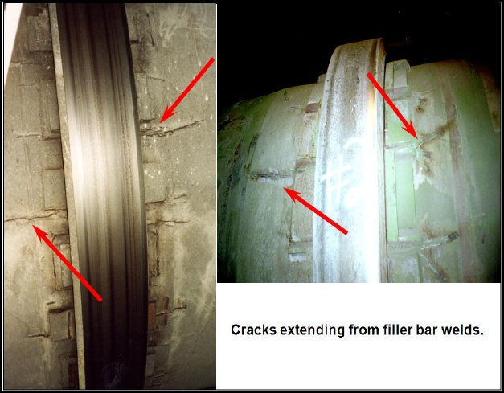
Figure 1 : Cracks extending from filler bar welds
The unit walk – by stars with the shell, the unit’s largest component and then covers all its support and drive components. Each chapter of this manual completes a section of the walk – by. Your own walk – by should be conducted daily, with the main focus on changes in condition from one day to the next.
This chapter focuses on shell inspection and the three main areas of shell stress: cracks, permanent shell damage from thermal distortion, and temporary shell problems caused by unit misalignment.
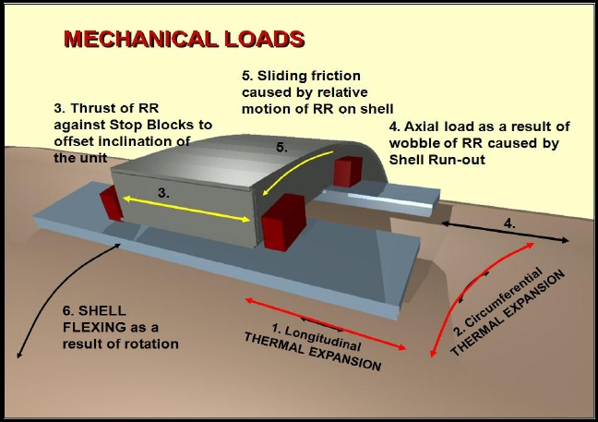
Figure 2 : mechanical loads
2.3 CRACKS
The severest sign of shell stress is cracks in the steel plate. The shell stresses that lead to cracking are caused by following factors:
Thermal expansion
During the normal operation of any kiln shell the temperature fluctuates, causing the shell to expand and contract. The tire support pads expand and contract at a different rate than the shell, creating stresses in the welds uses to attach the bars to the shell. These stresses are created from both longitudinal and circumferential forces.
Friction
Tires are mounted loosely on shell to allow for the different rates of thermal expansion of the tire and the shell. As a result, the tire will have circumferential movement relative to the shell. This is referred to as creep or slip.
There is generally a sliding component from this action that creates stress in the welds attaching the tire pads to the shell.
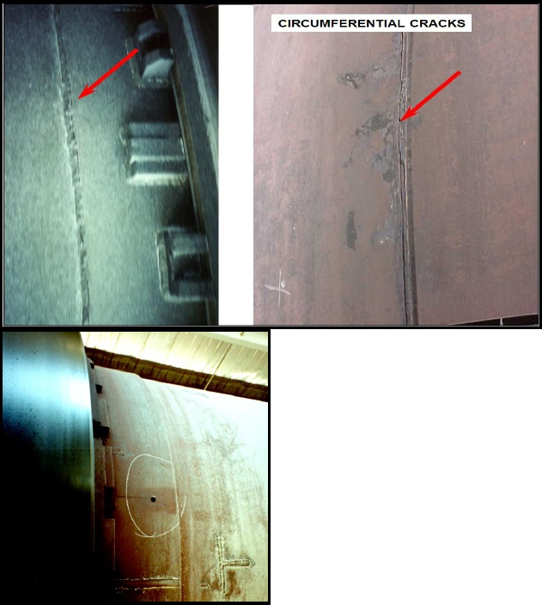
Tire thrust

As the unit is moving axially by carrying roller adjustment or thrust roller positioning, a force is transferred from the tire to the shell. This force is applied on the retaining rings or tire stops and consequently causes stress in the welds that attach the tire stops and the support pads to the shell.

Figure 3 : circumferential cracks

Ovality
Excessive ‘ flexing ‘ of the shell as it turns cause stress in shell plate. The welds that attach the tire support pads create a ‘ stress riser ‘ that can lead to fatigue cracks in the shell plate.
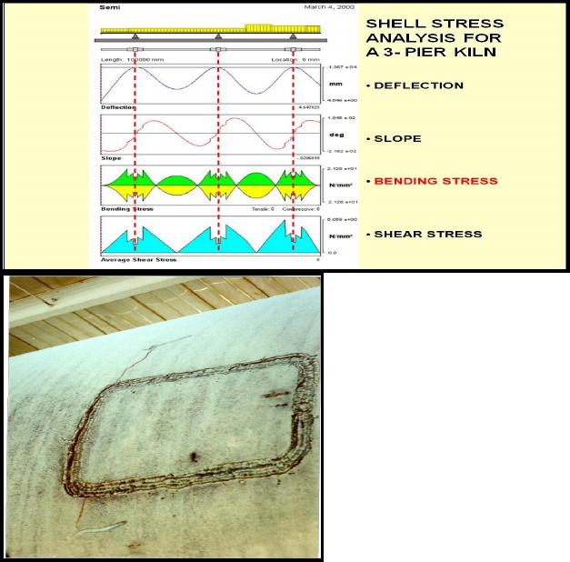
Drilling the end of a crack, 1/4 to 1/2 ( 5 to 10 mm ) diameter is a temporary measure used to try to stop the crack from propagating. It is important to try to do this as soon as a crack is detected. Circumferential cracks are far more dangerous than longitudinal cracks as they may travel sufficiently around a shell in a short period of time causing catastrophic failure.

Circumferential cracks most often occur on or near a circumferential weld seam or at a shell opening such as a manhole or a patch plate. They are the result of poor quality welding.

Circumferential cracks can also be the result of an undersized shell plate or lack of an adequate transition area where a thick plate joins a thinner plate. If a unit is not in proper mechanical alignment, as it makes countless revolutions, the operating stresses on these seams will eventually cause weld seam failure.
Periodic shutdowns are extremely stressful on rotary equipment and produce rapid expansion and contraction of the whole shell. Welded seams are subject to the greatest stress.
Any stress riser on a shell is a potential origin for cracks. Here we see a poorly welded ‘ window ‘ or coupon in the shell which has caused the problem. All unnecessary welds, lugs, or other miscellaneous items attached to the shell should be removed and the weld scars carefully ground away. Any such item can lead to shell cracking.
The deflection and slope curves are important because it is used by the kiln designer to locate the support piers such that the slope of the kiln shell is parallel to its design slope. That is slope value should be zezo at the center of each support ( the red dashed lines ). Note also how the shell sags between piers. When a kiln is modified by a change in length, change in loading or change in the number of support piers, the disregard of shell sag can lead to aggressive tire to side stop block rear.
The shell bending stress curve is used to determine the shell plate thickness. Note that the saw tooth tips along this curve are where the shell plate changes thickness. The stress on the kiln shell is greatest at these points and so these circumferential welds should be the focus of your attention when making your daily inspections.
The shear stress in a typical kiln shell is very low and is rarely if over a cause for failure.
2.4 NON- DESTRUCTIVE TESTS ( NDT) FOR SHELL CRACKS
ULTRASONIC AND X-RAY EXAMINATION
- REQUIRES EXPERIENCED TECHNICAN
- SHOWS SUB-SURFACE CRACKS
- HELP DETERMINE EXACT EXTENT OF CRACKS
DYE PENETRANT & MAGNETIC PARTICLE INSPECTION
- EASIEST TO PERFORM
- LIMITED TO SURFACE CRACKS
- USED PRIMARILY DURING REPAIRS
After a crack has been identified by visual inspection, a more through inspection using NDT ( Non – Destructive Testing ) methods should be planned for all suspect areas. NDT is performed with ultrasonic, or magnetic particle inspection, and dye penetrant.
Ultrasonic and x-ray testing requires trained technicians. Most companies do not have this expertise in – house, so an outside contractor is employed. Both of these method identify subsurface cracks, which is important in defining the extent of cracking, so a repair scope can be developed.
Dye penetrant testing is probably the simplest NDT procedure to perform and can usually be performed by site technicians. Its use is limited to surface cracks and is a valuable tool in the actual weld repair procedure.
Cracks are a sign of total failure and should never be ignored.
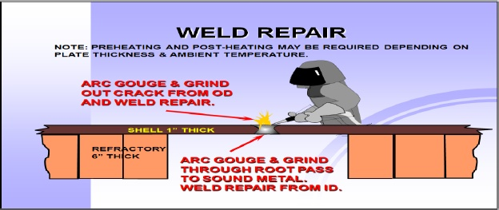
2.5 WELD PROCEDURES
When undertaking shell crack repair, a procedure must be developed that considers the type of material, the thickness of the plate and any adverse conditions, such as extremely cold ambient temperatures at the time of repair.
In general, the repair will require air are gouging and grinding to remove the cracks from both the inside and the outside of the kiln. This will ensure a successful repair by completely removing the crack and fully penetrating the weld repair. Welding over the top of the cracks is a waste of time and money. The shell must be cleaned of all materials from previous welds.
Any weld repair made during adverse weather conditions such as rain, snow, and cold ambient temperature, will require special precaution, such as preheating the shell to at least 150ºF/65ºC to remove chill or moisture. The temperature should be monitored with temperature sticks. Tarps should be set up to provide protection to the weld repair area. It is critical that all weld on a kiln shell be of the highest quality because of the thermal and mechanical stress present in a kiln.
If a crack migrates under a tire, the tire must be moved in order to make the proper repairs. If the unit is refractory-lined, the refractory area of the repair will need to be removed and replaced. The underlying cause of the crack should be understood and corrected to avoid reoccurrence.
2.6 PLAN OF ACTION IF SHELL RIPS
A. shut the unit down and position it where the emergency repairs can be most easily performed.
Weld ‘ strongbacks’ perpendicularly across the face of the weld tear. A ‘ strongbacks ‘ is a piece of A-36 iron approximately 1^{1/2’’} thick by 6’’ – 8’’ high, and long enough to bridge the weld tear by at least 12’’ to 14’’ on either side.
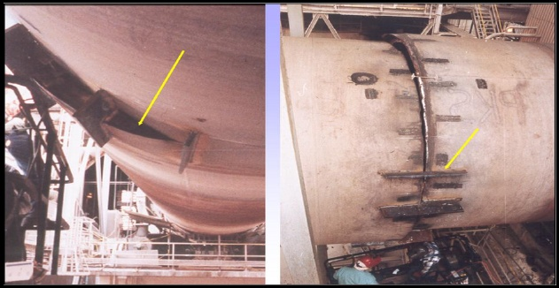
Figure 4: ripped shell
B. bring the unit back up long enough to completely run out the product that was in the unit at the time of the breakdown.
C. remove approximately five feet of brick on either side of the weld tear.
Refractory may already be missing due to the sudden misalignment caused by the weld tear.
- Position the unit where the ‘ strongbacks ‘ are removed and install adjustment hardware on the inside of the unit to reunite the separated parts of the kiln shell.
- When the seam is welded together on the outside, remove the adjustment hardware on the inside. Back gouge and weld the seam. Grind the seam as flush as possible.
- It is necessary to install new ‘ strongbacks’ around the circumference of the failed seam. Otherwise the weld failure will move to the part of the shell that does not have the benefit of the additional repair hardware.
This method is a Band- Air! Because shell stress and misalignment are present, the unit will not perform properly. Catastrophic failure will occur elsewhere on the unit if proper repairs are not made. Installing a new shell section at the area of weld failure, coupled with complete alignment analysis, is the most likely plan of action.
As a result of the unit being suddenly stopped and allowed to cool in one position, the kiln shell will sag between piers. This in itself not the cause for alarm. The sag will diminish as the unit is brought up to production temperature. Generally not all of the sag will disappear but the unit will true it well enough to operate.
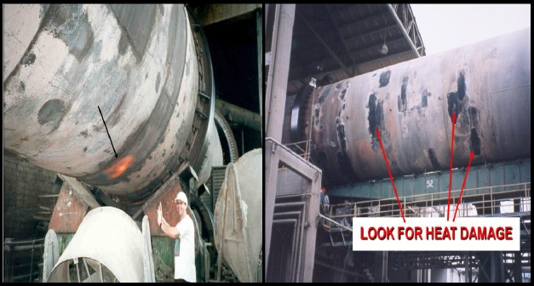

Figure 5 : hot spot and heat damage
2.7 HEAT DAMAGE
Refractory – lined shell are prone to heat damage. When refractory fails, an area of the shell is superheated and hotspot occurs. A hot spot is seen as a bright red or yellow area whose size can be as small as one brick or a much large area. Blisters or bubbles on the shell are also indicators of a serious heat problem which should not be ignored.
Thermal scanners use infrared beams strategically positioned to monitor a unit’s shell temperature during operation. These devices incorporate sophisticated software programs to show you a real – time temperature as well as historical data on temperature in various zones of the kiln. A scanner can work well as a preventive tool by providing information on potential problem areas, and allowing steps to be taken before refractory fails and shell damage occurs.
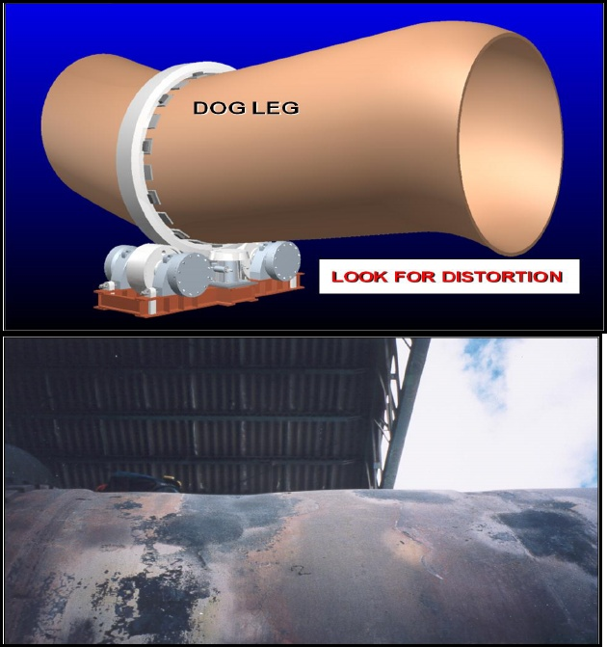
Figure 6 : shell distortion
As the hot spot cools, it shrinks, flattens and discolors, often to black. This shrinkage which is a result of the metal yielding during the time it was heated to the annealing range, 1125ºF to 1250ºF/650ºC to 675ºC, affects the roundness of the shell.
When one area shrinks it may cause another area to bulge. The shell, generally considered to be a cylinder, no longer has a straight axis. It is now bent, or kinked, or as it is often described in extreme cases, it has a ‘ dog led’ or a ‘ crank shaft’ condition.
2.8 DISTORTION FROM HEAT DAMAGE CREATES OTHER PROBLEMS
Distortion which is a bent axis creates a multitude of problems depending on their magnitude and location. In a localized area this out-of-roud condition, whether it’s a flat spot or a bulge, can make it difficult to achieve quality refractory installation. Premature refractory failure due to mechanical instability often results.
Since the shell is no longe rolling as a straight cylinder it is subject to additional bending stress as its weight cycles from one roller to another. In extreme cases, a portion of the load shifts from pier to pier. The rollers, shafts, bearing and bases, which are designed to support a portion of the total rotating load, now bear a reduced load for part of each revolution and a higher load for the balance of each cycle. A badly bent shell can induce extremely high load peaks during each rotation cycle. In addition to the shell problems, this overloading can lead to shaft failure, hot bearing or even support base damage.
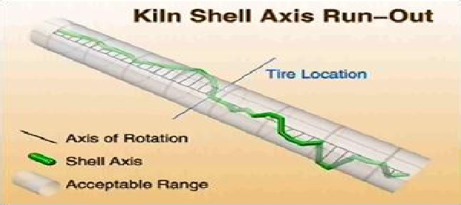
Depending upon the location of the bend, the ‘ dog leg’ or ‘ crank shaft’ can also cause tires to wobble. Wobbling tires not only exert cyclical loads into the rollers and shaft but also reduce the contact area between the tire and the rollers. This increases the contact pressure. If excessive, this can cause surface spalling or the tire and the roller faces. The tire wobble also makes proper roller skewing difficult, if not impossible.
In the area of the girth gear, this will affect both the radial and axial run out of the gear, causing accelerated wear of the gear teeth. Depending on the location of the ‘’ dog leg ‘’ the scal may be adversely affected as well.
Correcting the problem: depending upon the nature of the distortion, it may be possible to reduce the bend in the shell by using localized heating and cooling procedures. Results are not exact or reliable. In most case a replacement shell section is required to affect a reliable repair.
2.9 MISALIGNMENT
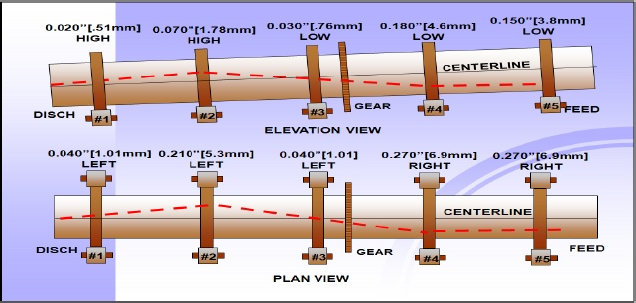

When the support rollers are not set correctly to proportionally share the rotating load, the kiln is misaligned. This condition cause serious overloading stress condition, similar to those caused by a bend in the shell. In contrast to cyclical load imbalance caused by a bend in the shell, misalignment creates constant load imbalance because the rollers are not holding the shell straight. The magnitude of the overloading is in direct relationship to the magnitude of the roller displacement. The effect of misalignment can be the same as a permanently deformed shell : cracks, premature refractory failure, hot bearings, etc.
Obvious signs of misalignment are excessive flexing, refractory failure, plate cracking and roller shaft failure. One of the most obvious signs of misalignment is a rise in amp usage. If amp usage is suddenly up, something is wrong.
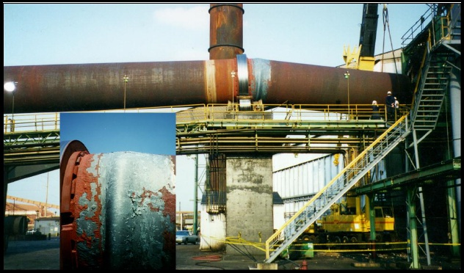
Misalignment cannot be detected visually nor can it be determined on a trial-and-error basis as can roller skew. In order to determine misalignment requires careful alignment measurement and specialized tool and procedures. These procedures are covered in the section ‘’ alignment analysis ‘’
Alignment measurement is performed by an outside service organization since very few companies have a large enough number of units operating to warrant the expense of acquiring specialized equipment and retaining qualified staff to perform this task.
2.9.1 WHEN SHELL IS MISALIGNED
Or has distortions causing a bend in the shell….
- Excessive flexing
- Refractory failure
- Plate cracking
- Roller shaft failure
- High power drive
2.9.2 ALIGNMENT MEASUREMENT SHOULD BE PERFORMED
Unlike cracks or heat damage, kiln misalignment cannot be detected visually. Careful alignment measurements and analysis of the results are the only way to determine if roller adjustments can reduce the stress on the kiln shell. Such adjustments one made where a significant misalignment existed often result in a dramatic drop in kiln motor amperage verifying that the energy used to turn the kiln has dropped.
2.10 CONCLUSIONS – WHEN PROBLEMS ARE VISUALLY OBVIOUS, IT IS TOO LATE!
Preventive maintenance require the use of analytical tools BEFORE damage becomes visually obvious. Some plants are staffed and equipped to handle analytical testing. Most plants look for outside help.
The problem of a damage shell, whether from cracking, abrasion, erosion, heat distortion, or misalignment will always lead to further problem? The shell is the largest component of a rotary unit and it is predictable that when something is wrong with it you will begin experiencing related problems, such as aggressive component wear and carrying roller adjustment problems.
Problem that have not yet produced visual symptoms must be identified. This involves using analytical ( measurement ) tools. Some plants are staffed and equipped to handle analytical testing. Most plants will look to outside help.
Understanding the mechanical function of all the parts and being able to identify what areas need attention, will allow you to make the decisions about what can and cannot be handled satisfactorily in house.
Identifying the symptoms early and utilizing the proper analytical tools can allow time to formulate and implement a plan of action. Failure to doso in some cases can lead to catastrophic failure or unplanned outages.

It is impossible to restrain the effects of thermal expansion on the steel shell. The shell components, the tires and the filler bars, also undergo thermal expansion. Because the expansion rate of the components is usually unequal to that of the shell, the problem of managing these differences becomes a primary focus for maintenance personnel. The way the tire and filler bar are mounted on the shell plays s large part in solving the problem of unequal thermal expansion.
Any time that inspection of a rotary unit is carried out, the tires and tire elements should be carefully examined. One a small problem develops with these components, larger problems are sure to follow.
3.1 TIRE MOUNTING – 2 CLASSES
FIXED
FOR UNITS WITH SHELL TEMPERATURE LESS THAN 200^{O}F/100^{O}C
LOOSE ( MIGRATING, FLOATING )
REQUIRED FOR REFRACTORY – LINED VESSELS
Riding ring/ tires provide substantial strength to the shell by maintaining shell roundness. Must of the shell’s integrity is directly related to the thickness, width and mounting style of the riding ring. Riding rings can be manufactured from cast iron and cast steel. They can be cast and hollow, forged and rolled, or fabricated, multi – pieced and segmented. A typical kiln riding ring is manufactured from 1045 normalized material or its equivalent, and hardness typically falls between 180 BHN and 220 BHN.
In the broadest sense tires can be put into two classes : fixed tires and loose, migrating or floating tires. Fixed tires are usually found on unfired vessels and equipment whose shell temperature is below 200 ºF or 100º C. loose tires are mormally required to accommodate diferential thermal expansion between the tirte and the shell, especially on those shell whose surface temperature is high.
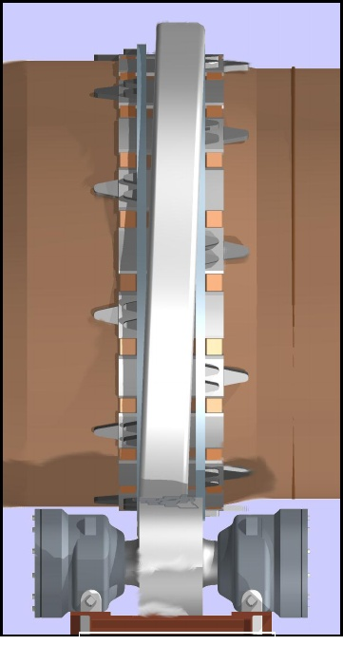
FIXED- there are many ways a tire may be fixed on the shell. Some are welded directly to the shell. Others may be wedged, pinned, keyed, splined, blocked or otherwise mechanically fixed. Fixed tires that come loose must be identified and repaired. If tires require frequent repair, an evaluation of the method of mounting should be made.
LOOSE – Loose tires are inherently more difficult to maintain because the “ migrate “, meaning that by design they are free to rotate on the shell. This migration, even when sufficient and controlled, and even when appropriate lubrication is present, will wear the mating parts ( filler bars, stop blocks, roller, etc.). a migrating tire also becomes a problem when it becomes too loose to properly support the shell.
3.2 PROBLEMS OF LOOSE ( MIGRATING ) TIRES
- Wear occurs on OD of filler bars.
Figure 7 : migrating tires
- Some wear on tire ID.
- Wear on both sides of tire and stop block.
- Foreign objects can wear and groove.
The tire migrating on the shell, whether the tire was meant to move or not, will wear the tire bore and side walls. The tire side walls, more than any other area, are subjected to the severest duty. Visual signs of distress on the sides are a clear indication that a problem exists. Signs of distress could be rolled edges, cracks or undercutting.

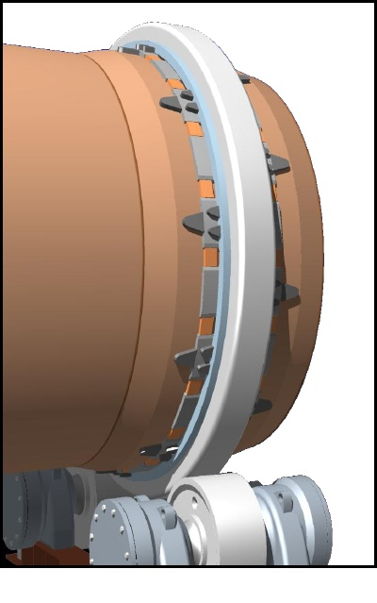
Problems arising from migrating tires are usually found in a combination of varying degrees with other problems : warped shell, misaligned rollers, mis – skewed rollers, out-of-slope rollers, and differential shell slope.
3.3 FILLER BAR DESIGNS
- FULL FLOATING
- SEMI-TRAPPED
- WELDED
- RIM-MOUNED ON SHELL ( BODY FIT )
- SPLINED OR TANGENTIAL SUSPENSION
Refractory-lined shell requiring floating tires demand the most service performance from the tire mounting components. Over the years the “ full floating filler bar “ design has evolved and provides the best compromise to meet the conflicting service demands of the migrating tire mount.
Figure 8 : full floating filler bars
3.4 AVANTAGES OF THE FULL FLOATING DESIGN
The filler bar, the largest component of the various parts, is not attached to the shell in the full floating design. This is important since the bar’s expansion rate is different from the shell. The designs which weld the filler bar to the shell tend to be problematic.
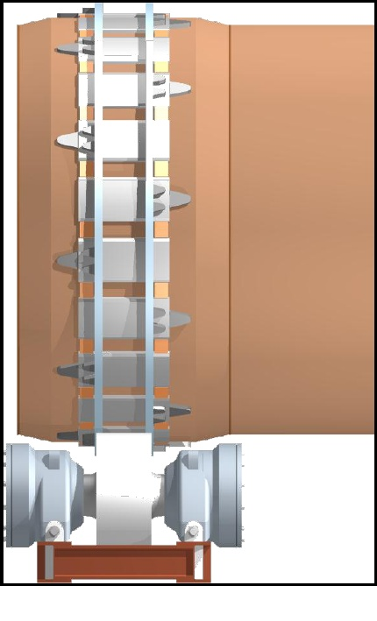
The full floating design incorporates retaining rings which bear against the side of the tire, providing a much large bearing surface than former designs using only stop blocks. Significantly reduced wear results. The retaining rings are keyed to the shell so that the wear surface is the side against the tire and not the side which contacts only the keepers.
The filler bars can be removed, exchanged, or shimmed without cutting or welding the shell. This design is a little more expensive than other filler bar arrangements because more parts are necessary and installation time is increased, but overall it is the most serviceable and cost-effective arrangement.
Figure 9 : semi trapped design

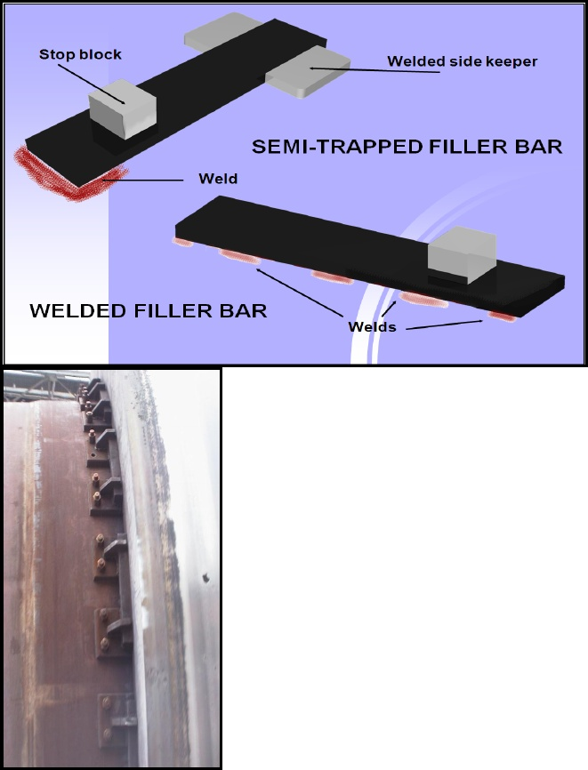
3.5 SEMI-TRAPPED DESIGN
This design involves fewer parts than a free floating design so it is a little less expensive to install. It allows the filler bar to expand and contract, however it still has the potential for the weld to crack.
3.6 WELDED DESIGN
This design was used for many years and is still commonly found. However, the welds always crack so this design is generally not used on new installations, and is being phased out when filler bars are replaced.
Figure 10 : bolted design
3.7 BOLTED DESIGN
Bolts are used to attach the bars to the shell. Look for loose bolts and bolts that are missing or have sheared off.

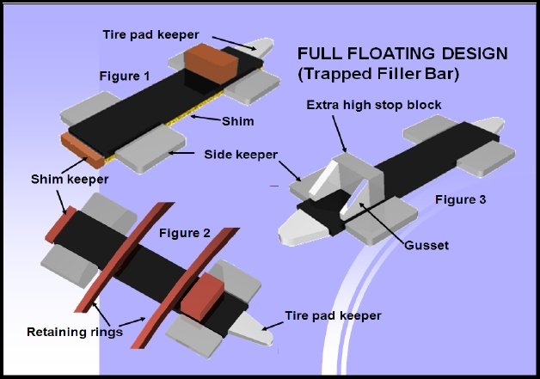

When making an inspection of the filler bars of any type, be particularly aware of any cracks, loose welds, or rolled edges. Often the smallest filler bar problem can lead to the largest shell problems.
The floating filler bar design eliminates weld cracks caused by thermal expansion and contraction.
3.8 TERMINOLOGY
A. Welded Filler Bar : also called a tire pad. Weld to the shell
B. Floating Filler Bar: not welded to the shell but held in place by keepers and stop blocks.
C. Side Keeper: welded to the shell.
D. Stop Block: welded to the top of the filler bar. Provides a bearing surface for the tire.
E. Shim: welded to the bottom of filler bars to accommodate an out of round shell and to get accurate gap between the filler bar and riding ring. Size is adjusted to allow for welding. Example : FB = 1”x12”x28”, Shim = 1/8”, 1/16”, and 1/32”x11.5”x27.5”.
F. Shim Keeper : welded to the shell. Keeps the shim from slipping out from under the filler bar if it not welded.
G. Retaining Ring: located between the stop blocks and the edge of the riding ring. Provides a larger bearing surface than a stop block.
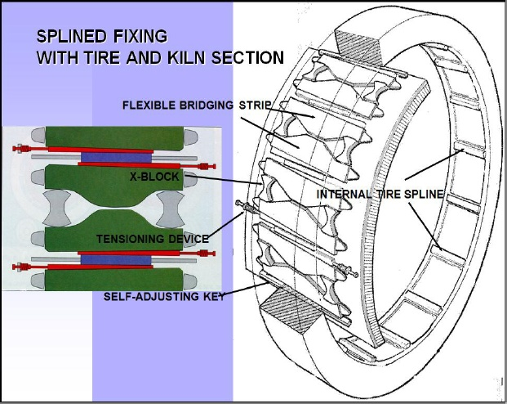

3.9 SPLINED DESIGN
In this design the load of the rotary kiln is transmitted, via the X-shaped retaining blocks welded to the shell, to the floating tire shoes, to the wedges, then to the tire splines. The shell is supported by the tire at 3 o’clock and 9 o’clock. Consequently there is almost as much gap at the bottom as there is on the top although ovality still makes the top gap large. The ovality for this type of shell support is about ¼ as much as with conventional designs.
The clearance between the tire splines and the shell pad is taken up by the slow wedges. As this clearance varies with tire to shell temperature difference the wedges migrate in and out. This result in a tight assembly circumferentially at all temperature and yet leaves room for the shell to expand/ contract radially within the tire.
Advantages:
- Minimum and stable ovality of kiln shell, irrespective of tire clearance.
- No thermal stresses, since there is no impeded thermal expansion.
- Because the tire shoes have high elasticity there is uniform support of each fixing unit, even when the kiln shell temperature varies.
- Separate reception of bearing load and the axial load.
- Provides torque transmission from the tire to the kiln cylinder.
3.10 MEASURING “ CREEP”
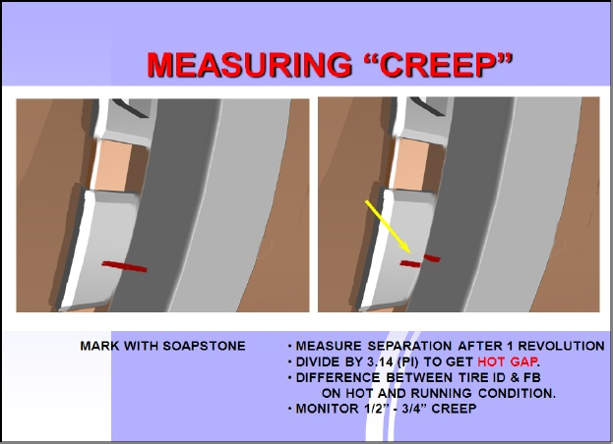
The riding rings provide substantial strength to the shell by maintaining shell roundness. Because the shell naturally flattens out at the 12 o’clock position like a balloon full of water, the riding rings system must maintain shell shape by preventing flex. A support system must also provide an accurate and ridged method of mounting the tire to the shell.
By design there is a difference in the size of the shells outside diameter ( OD ) and the tire’s inside diameter ( ID ), the tire having the greater diameter. Because of this difference the tire naturally wants to creep, or migrate at a slower rotational speed than the shell. The shell is actually rotating at one speed and the tire is lagging behind at a slightly slower speed.
By making a mark with soapstone from the side face of the tire to the surface of a filler bar, or along a stop block, it is possible to witness the mark slowly separate from the two surfaces during each rotation. This separation is a direct measurement of the fit between the shell OD and the riding ring inside diameter.
THE BEST METHOD OF MEASURING GAP IS TO USE THE – “ OBOURG “ METHOD
When we go to the top of the kiln and measure the actual gap we find that it is larger than the difference in circumferences ( Tire bore circumference less shell filler bars circumference ) divided by π. The reason for this is ovality, meaning the shell sags across the top. Another way to think of this is that the shell and tire are not perfect eccentric circles. If they were then the gap would be equal to the creep/π.
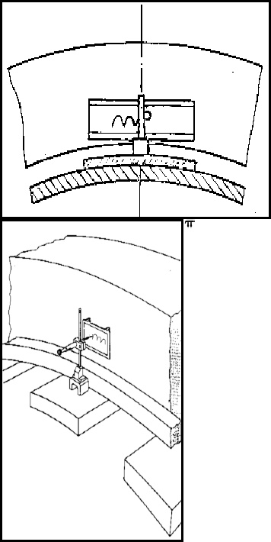
Even this assumes that the creep is the result of true rolling action with no slip or hang-up.
The Obourg device shows us the complete story. It shows us the relationship between slip, gap and the effects of ovality.
The amplitude “s” of the resulting plot is the actual gap. The period “ ∆U “ is the prevailing creep. ∆U / s ≠π but something more likes 2 to 2.5. this ovality ratio varies from kiln to kiln and tire to tire.
This may seem like a very academic issue but it has great significance when it comes to calculating the expected filler bar thickness when reducing the gap to correct ovality is necessary.
Although this an excellent diagnostic tool its use is often limited by the presence of thrust rollers and high speed kilns.
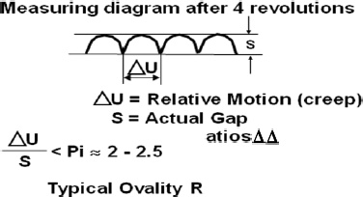
Typical Ovality Ratios
PROBLEMS CAUSED BY EXCESSIVE WEAR AND CREEP
- Wear accelerates as creep increases
- Shell ovalities increases which leads to:
- Brick failure due to crushing
- Shell fatigue caused by constant shell flexing.
- Cracking in shell and plate, weld seams and filler bar welds.
- Tires can wobble if they are too loose and can get cocked on the shell.
- Stop blocks and retainers wear out then undercut tires. Undercut tires lead to the continuous problem of matching up stop blocks.
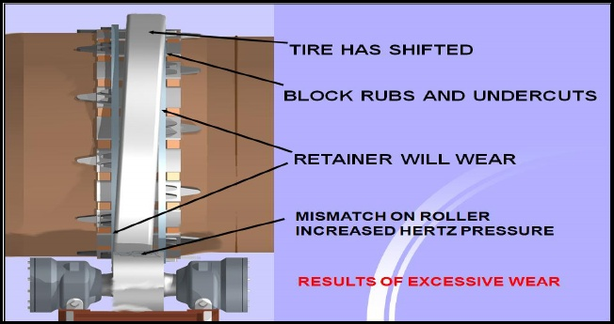
- there is a direct relationship between the number and types of supports under a riding ring, and their ability to distribute the unit load to the shell. Worn filler bars, or supports, allow excess gap at the shell’s 12 o’clock position, thus allowing, excessive flexing or flattening. This reduces the shell support provided by the riding ring, accelerates and compounds support pad wear, and leads to shell cracks. Cracks are a sign of complete failure and will eventually adversely affect the total operation of the rotary unit.
Excessive wear also allows the shell to move through riding rings, which mismatches the rings to the rollers and the gear and pinion. This then increases the loads at contact area of the rings and rollers, gear and pinion, and increases hertz pressure which leads to surface spalling.
When there is wear on the tire it will become more and more difficult to make adjustments to the tire, and there will be gear and pinion wear, or even failure.
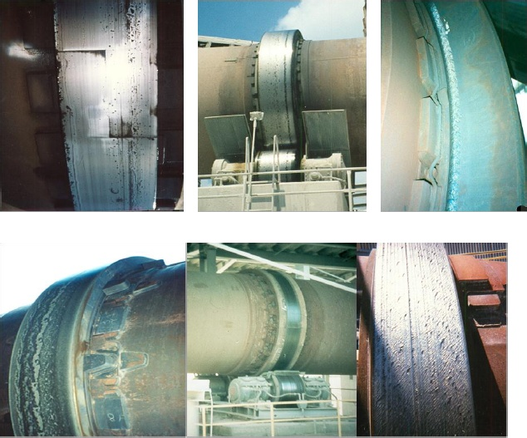
Figure 11 : several types of damage on riding rings

Surface deterioration of the tire is also a sign of failure. The presence of surface craters on the rolling face of the tire, commonly referred to as spalling is a sign of metal failure.
There is always some metal distortion present in the pinch point between the roller and tire. On a microscopic level this can be seen as an area flattening out, similar to that of a rubber tire on a car where it contacts the road. When a tire starts to wobble or if for some reason the pressure in a localized area of the pinch point becomes excessive, the distortion of the steel will go beyond the elastic limit. The flexing of the work-hardened layer against the underlying softer mass will create cracks between them. Once subsurface cracking starts, it propagates until chunks of metal break free.
Ultimately, spalling, and the reasons for it, can cause the tire to crack in half.
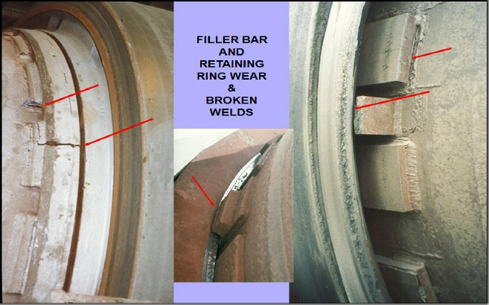

Worn or broken filler bars, and the resulting loose tire, will produce hhigh ovality readings. Ovality measurement is a standard practice for measuring how much a shell flexes. This technique was developed specifically for keeping an eye on how much flexing the shell exerts on the refractory lining. It is discussed in detail in a separate section called “ Ovality Analysis “.
Also of concern is the extent of wear at the sides of the tire where it comes in contact with its retaining bars or stop blocks. With high loading, these blocks or bars will also be worn. Visual observation of the space between the tire and these parts gives a good idea of what is going on. For a new assembly this space is only about 1/16”. Average space after years of operation will show about ¼” to ½” space. Any more than that and the tire may run off the face of their rollers and the gear may misalign on the pinion.
Heavy side loading of the tire against these retainers will also cause the retainers to break off. Sometimes these may be welded on and the welds will break. If they are bolted on, the bolts may shear. No matter how they are mounted, cracks and heavy wear are easy to spot and are a sure indication that something is wrong.
Typically, mis-skewed rollers or a bent shell are the principal reasons for this kind of damage. There are other reasons for this to happen as well. Fixing cracks and worn parts, or replacing missing pieces may not resolve the problem. It is important to carefully analyze the condition, since redesigning the way the tire is retained may be required.
3.11 CORRECTING PROBLEMS.
A. REPLACE TIRE IF DAMAGED BEYOND REPAIR
B. GRIND TIRE AND ROLLERS SO THEY ARE SMOOTH
C. REPLACE FILLER BARS AND STOP BLOCKS
D. REPLACE SHELL IF COLLAPED
If the problems you have observed are severe, you may have to replace the tire or roller. A way to solve a problem that has been caught early is to grind the surfaces of the tire smooth. The roller should be ground at the same time. ( see “ resurfacing and Grinding” section ). A third solution is to replace the worn filler bars and stop blocks. Doing this will not only replace worn out components but reshimming the filler bars will reduce creep.
If the shell has collapse under the tire and filler bars, a section may have to be replaced. This alone is a very good reason to be aware at all time of the potential problems inherent in the design of rotary equipment.
3.12 STEPS FOR REPLACING FILLER BARS UNDER A RING
A. DETERMINE THAT BARS ARE EXCESSIVELY WORN
B. CHECK FOR COLLAPSED SHELL.
C. TAKE MEASUREMENTS OF EXISTING BARS.
D. DETERMINE THE DESIGN OF THE NEW BARS
E. MAKE NOTES ON COMPONENTS CONCERNING.
a. TEMPERATURES NOISES
b. POSITION DAMAGE
3.13 THE QUESTION OF LUBRICATION
The question of lubrication between the bore of a migrating tire and the shell or shell bars that the tire fits on has always been controversial. Although lubricating the tire bore may seem to be a natural requirement of good kiln operation, some experts advise against it. One argument is that “ greasy “ lubricants may attract dust and debris which then act as grinding compounds and accelerate wear. The second argument says that lubrication will promote slippage and creep, again, hastening wear.
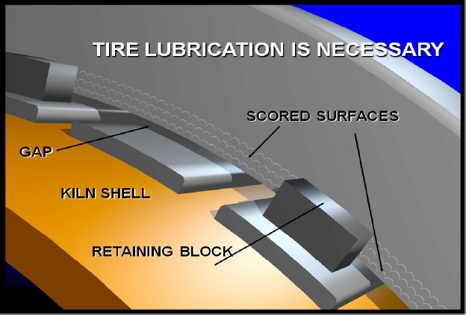
- Any dust and debris will be consumed by the grinding action, leaving nothing to gall the steel.
- Slippage will occur with or without lubrication.
True rolling action can never be assured and is at best, a transient condition. Lubrication, therefore, is not applied to induce slippage, but to prevent and local areas from galling and hanging up to the point where metal failure occurs. A greater amount of creep may be seen with the use of lubricant than without, which, if it acts to polish the surface, is infinitely more desirable than creep who is limited. Inhibited creep will eventually tear the metal.
Galling occurs when dry steel slides by dry steel and the surfaces attach themselves on a microscopic level and destroy themselves. The steel balls up and forms slugs or spitzers. These are created at the sides of the tire where they contact the retaining blocks. Lubricating here is essential to prevent undercutting the tire and consuming the stop blocks. Lubricating the entire area is completely appropriate.
Graphite is most frequently used for this application. Other lubricants specifically formulated for this are colloids containing molybdenum, aluminum etc. these are solid lubricating materials in a carrier that is designed to evaporate at low temperatures. In no way should this carrier be confused with “ grease “. The carrier quickly dissipates leaving solids as a non-sticky residue, which closely adheres to the surface of the steel components.
Lubrication does not correct misalignment but lubrication in the areas discussed is an important step toward good equipment maintenance.
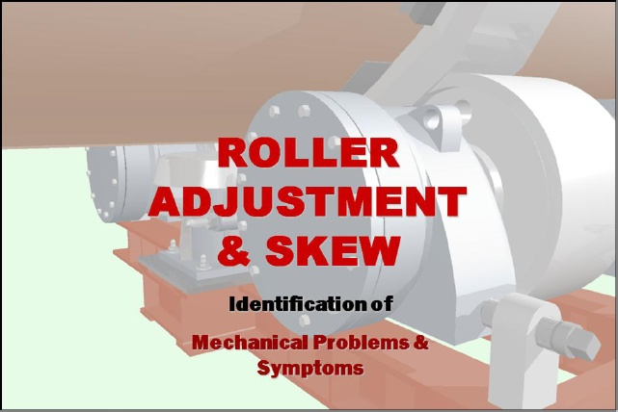
Roller adjustment can be classified in two categories.
- Alignment adjustment ( Discussed in detai in Alignment Procedures).
- Skew
Skew, more than any other mechanical adjustment, is the least understood, the most misused, and cause more mechanical problems on average than all the other adjustments that can be made on a kiln combined.
4.1 DEFINITION
Skew is the adjustment made to a roller by pivoting the roller on the midpoint of the roller shaft. This means making equal adjustments in opposite directions on the upper and lower bearing housings of a trunnion.
This pivoting adjustment only changes the parallel relationship to the longitudinal axis of the rotating shell, but does not affect ( to any significant degree) any change in the position of the shell either in plan or elevation views. In other words the rollers is pivoted but the shell is not raised or moved laterally.
This simple, but important concept must be understood completely before correct roller adjustments can be made. Thrust control by skewing may be the single most important adjustment which influences the optimum mechanical operation of the unit.
- WHAT IS SKEW?
- WHY SKEW ROLLERS?
- WHY IS PROPER THRUST IMPORTANT?
- WHAT IF MY KILN HAS HYDRAULIC THRUST ROLLERS?
- WHAT IF MY KILN IS A “ FULL THRUST “ KILN?
- WHY SKEW ROLLERS?
4.2 PRINCIPLE
The principal mechanisms for confining the axial movement of the shell are the thrust rollers. They prevent the shell from moving downhill, which is a unit’s natural tendency due to gravity and weight. Most thrust rollers are not designed to take the full load of the unit for even a very short period of time, unless the unit is designed with hydraulic thrust rollers or is a full thrust unit. ( there units are designed to accept the full thrust load on the lower thrust roller.). skewing the rollers properly will counteract the gravitational force of the kiln, and move the kiln uphill. Improper thrust can add to the gravitational force, overloading the thrust roller and causing failure.
Proper thrust achieves a somewhat delicate balance of skew on each trunnion so that the unit will lightly bump the lower thrust roller during operation. Too little skew will cause the unit to ride harder downhill than necessary, and wear on the lower thrust roller and the thrust face of the tire. Too much skew will induce an unnecessary amount of wear on the trunnion and tire faces, causing conical wear patterns to develop rapidly.
Skewing the rollers for proper thrust ensures that all rollers are thrusting in the same direction, and in like amounts. Uneven skew, i.e. one roller thrusting the kiln downhill and the other roller on the same pier thrusting the kiln uphill, or if the rollers on one pier are thrusting the same direction, and an adjacent pier is thrusting in the opposite direction, will accelerate the wear on the tire and trunnion faces, as well as cause other problems: increased power consumption, higher bearing loading, increased contact stress on the tires and trunnion, etc.
Good preventive maintenance begins with a complete understanding of SKEW.
To best understand the concept, we take a cylinder and a board. These represent the fundamental geometric shapes whose interactions illustrate what happens when skewing adjustment are made.
We place the board on the cylinder in a fashion to how a kiln or dryer tire ( the board ) sits on a roller ( the cylinder).
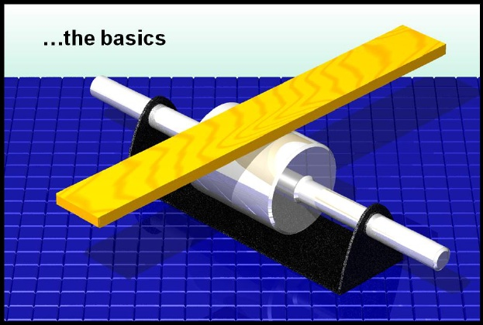
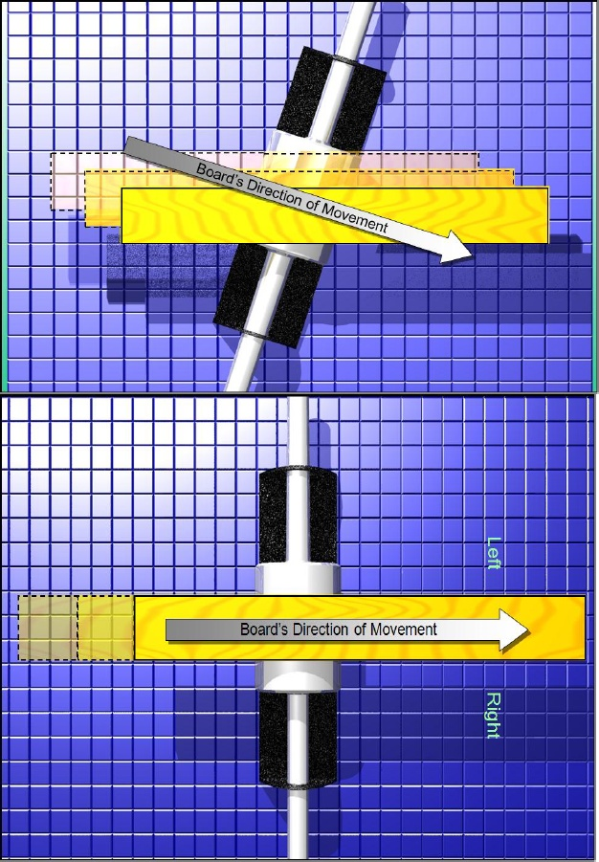
Looking from overhead ( the plan view ) the board is placed on the cylinder at right angles to the cylinder’s rolling axis. When the board is pushed so that it rolls on the cylinder it does not move either to the left or to the right.
This is referred to as the neutral position or zero skew.
If the cylinder is pivoted at its midpoint, its rolling axis is no longer at right angles to the board. Setting the board in motion ( straight ahead ) causes the board not only to move ahead but also to move sideways. The direction of the lateral motion of the board depends on the direction in which the board moves, forward or backward, and the direction of the skew.
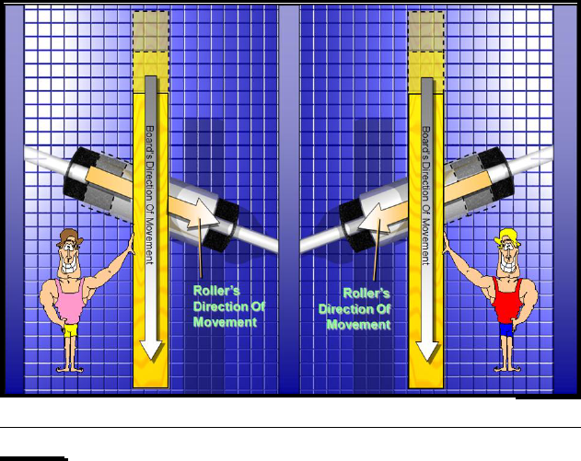
For every action there is an equal and opposite reaction. This is Newton’s third law of motion, for those of us who haven’t forgotten our basic physics. This means that if the board is held and prevented from moving laterally, then the roller would be forced in the opposite direction.
This reaction is very important to remember when trying to understand a roller’s shaft position within the bearing. When the cylinder is acting to roll the board to the right and the board is prevented from moving right, the reaction is for the cylinder to move to the left and vice versa. The same analogy applies when a roller is pushing the tire to the right and the tire is held, usually by a thrust roller, it forces the roller to move left. The shaft, which is only an extension of the roller, therefore also pushes itself to the left in the bearing housing. This is referred to as thrust. When the roller pushes the tire in one direction the roller reacts by pushing itself in the opposite direction.
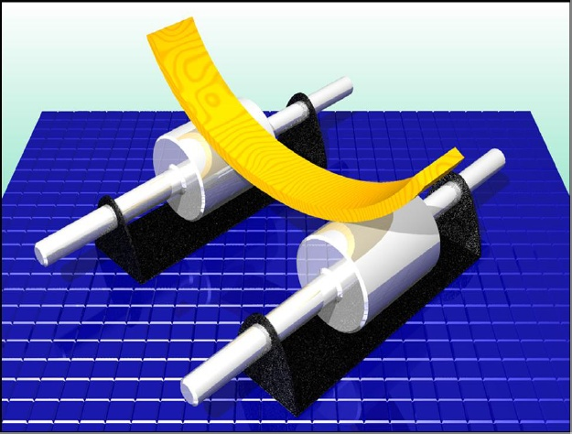
Curving the board so that it takes the same shape a shell tire, and supporting it on two cylinders instead of one is the last step to make the basic elements like a true tire supported by two rollers. Curving the board does not alter the action-reaction of skew but it does introduce other aspects which can be significant wear factors. First there is a change of pier to pier alignment. But since skew is so small this effect is not significant. Then there is an increase in local stress concentration on the rolling surfaces as well as the introduction of skidding or sliding. These last two can cause severe wear.
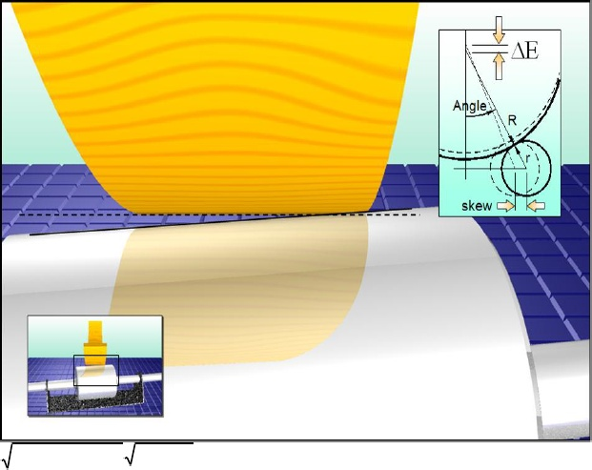
When the cylinder is skewed with the flat board sitting on it, the board does not change position in elevation or in plan view. When the board is curved as shown, and the rollers are skewed equally, two things happen.
- The board changes its elevation slightly
Assuming both rollers are skewed equally ( only to simplify the calculation ) the change in elevation is :
∆E $\sqrt{A^{2}-{(B-skew)}^{2}}$ - $\sqrt{A^{2}-B^{2}}$
A = radius of tire + radius of roller
B = sin ( angle ) x A
For a typical kiln : Angle = 30 degrees
R – radius of tire may be 2000 mm ( 79” or 6.5 feet)
r- radius of roller may be 500 mm ( 20”)
and the skew should not be more than 0.25 mm ( 0.010” )
DE is then calculated to be 0.14 mm ( 0.006”). the ratio is about 2:1 for easy reference. This ratio will not change enough to make a difference for any size kiln, cooler or dryer etc. although the skew is significant at 0.25 mm, the change in alignment elevation, DE is not.
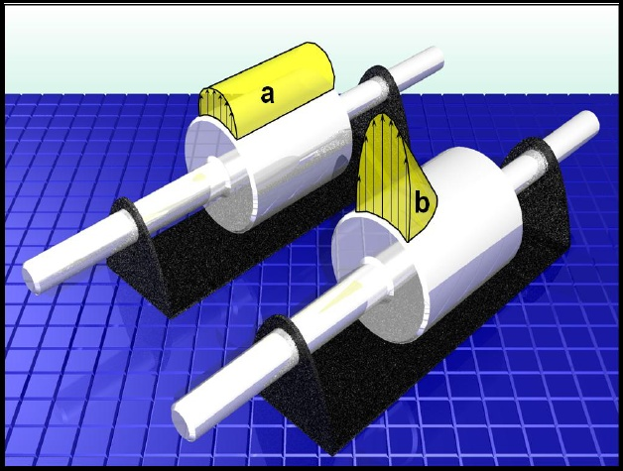
- The line of contact between the cylinders and the board changes. The line of contact is not really a line. It is an area defined by
- The length of contact between the roller and the tire in the axial direction.
- And the width of contact which varies according to:
- Roller diameter
- Tire diameter
- Hardness of the material
- Roller slope matching the tire slope
- Amount of skew
It is most desirable to have the area of contact as rectangular as possible. E.g … view (a). when skewing is required, which is the case for many by design, then clearly the minimum amount of skew to just balance the down thrust of the shell, should be sought. The skewing should be shares equally by all the rollers. For illustration purposes diagram (b) shows excessive skewing, so much so that only half the roller face is in contact. Since the load this roller carries has not changed, the stresses in this reduced area must necessarily be higher. Visually the stress volume of the yellow shape at “a” must equal that of “b”.
We can see therefore that excessive skewing decreases the contact area and increases the unit load, and stress, in that area. The contact area behaves similarly to a car tire in contact with the road. The contact area actually flattens out and the material in the flat area deforms. When this deformation exceeds the elastic limits of the material, it fails.
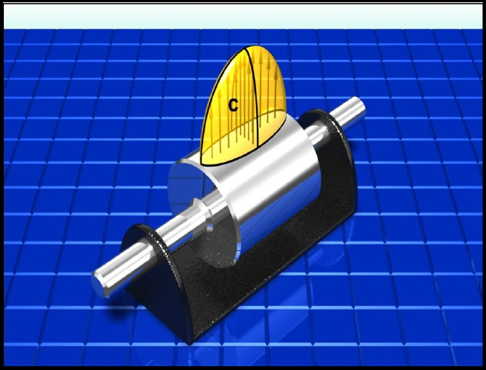
Skewing causes edge loading as seen in (b). this can be catastrophic if the skewing is excessive. The symptoms would include mushrooming, edge cracks in the rim and ultimately large pieces coming out of the loaded edge of the roller. Since some skewing is required in most cases, changing the roller slope by shimming is beneficial. Only bearing housing that have self aligning bearing sleeves or spherical roller bearings are easily adjusted in this way. Bearing housings with fixed sleeve bearing can be shimmed using tapered shims but this is a more complex procedure.
When the roller slope is adjusted for skew the load carried by the roller is distributed as show in “c”. the peak stress is moved back to the center of the roller; the stress reduces towards the edges and is symmetrically distributed. This is a much better distribution pattern and makes the effort to do this worthwhile.
On the upturning side of the kiln shell the downhill bearing is shimmed and on the down turning side the uphill bearing is shimmed. The shim thickness is about 0.6 times the amount of skew.
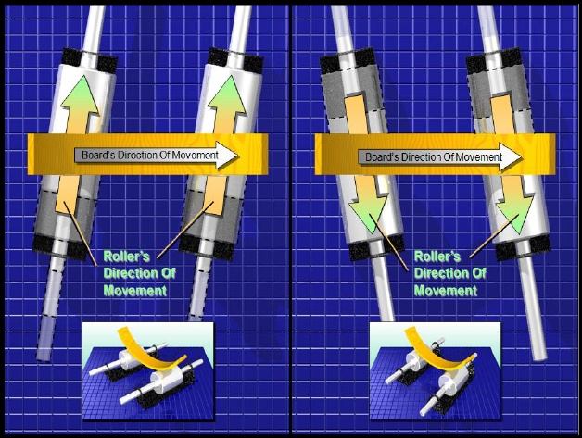
Now we put it all together. The curved board is the tire and the cylinder are the rollers. The effects of skewing the cylinders have exactly the same effect on the curved board as it does with the flat board. Skewing cause the ring to be roller into the direction the contact surface of the cylinder is moving. Since the rings are prevented from moving laterally this cause the rollers to shift in the opposite direction. As longs as the roller is free to shift it continues to do so until the roller shaft reaches and seats on the thrust bearing.
When neither the ring nor the roller can shift, the thrust load is relieved by slippage. Therefore, with skewed rollers we no longer have pure rolling action. Slippage is another effect that cause problems. It can tear the rolling surfaces. At the same time sufficient thrust bearing capacity has to be provided by the support roller bearing assembly. It will almost always be possible to have an overly skewed support roller generate more thrust than the thrust bearing can handle. The oil film in the bearings becomes too thin, metal to metal contact occurs, the surfaces heat up which in turn reduces the oil viscosity further, and the bearing fails. Once the thrust bearing fails the heat generated is usually enough to fail the support load both act on the bearing simultaneously. These will tend to fail more frequently than journal bearings with thrust rings or thrust buttons.
Since a skewed roller no longer runs against the tire with a pure rolling action, but induces some slippage, lubrication of the outside diameter with dry graphite is highly desirable, and helps preserve the surfaces. Oil lubrication on the rolling surface should be avoided as it can promote spalling.
Once again we have good cause to avoid skewing when possible and to limit it to a minimum when it is required.
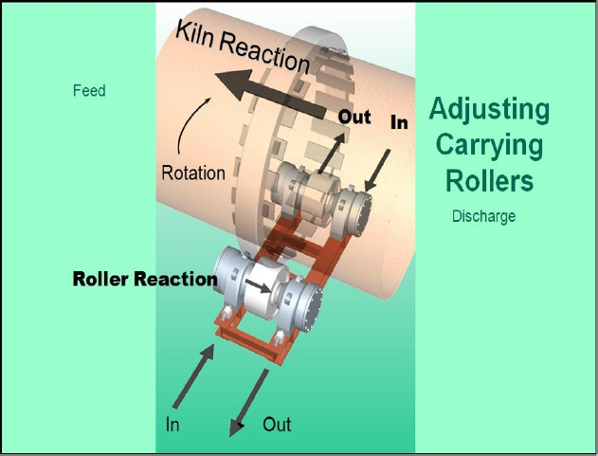
PUTTING IT ALL TOGETHER
By looking at a full roller support station assembly we should easily be able to predict the reaction of the shell to a skewing adjustment of the rollers.
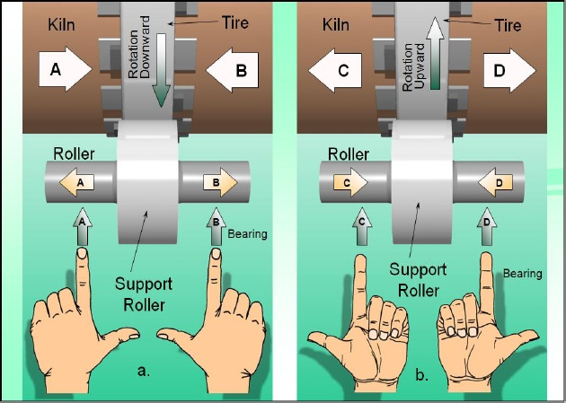
4.3 THE HAND RULE
Until you get used to visualizing the actual motions of the roller and tire, this “ hand rule” may help sort things out.
The palms: Stand and face the tire as it moves in front of you. If the tire surface is moving up-hold your hands out, palms up. If the tire is moving down-hold out your hands, palms down.
Fingers : Curl the fingers into your palm. They point into the direction the top of the roller is moving. When palms are up the fingers curl up towards you which is the way the top of the roller is moving. When palms are down they curl down and away from you, again the way the top of the roller is moving.
Index finger : Points to the direction which the bearing is to be moved.
Thumb : Points to the direction the shell will move as a result. For (a) pushing the left roller in will cause the shell to move to the right, and so on.
Remember, the thumb points into the direction the shell will move. The roller reacts by shifting itself in the opposite direction of the shell.
ALWAYS USE AN ADJUSTMENT LOG BOOK.
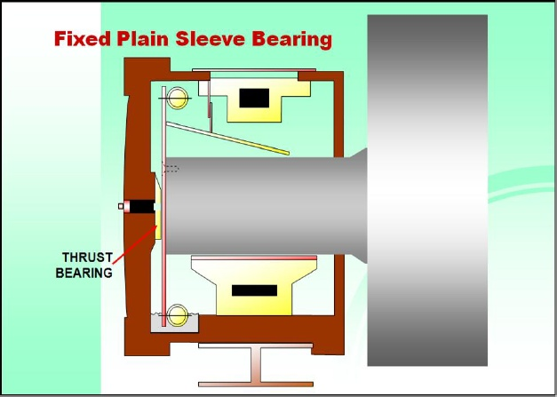
4.4 DETERMINE THE BEARING STYLE
Type I.) Fixed plain sleeve Bearing with thrust buttons on the end caps.
CHECKING AND DOCUMENTING THRUST
Checking the thrust on a housing that has the thrust buttons in the end caps is pretty simple. Using a 3 or 4 LB hammer, and lightly striking the and cap on or near the center, will produce one of two different tones. One is a hollow “bong”, or empty sound, which indicates that this end cap has no load on it. The other sound is a very solid, high “ping” like striking an anvil, indicating that the roller is loading up against this end cap. This style of roller is considered a “ pusher”. When thrusted, the shaft will load up against one end cap and push the kiln in the opposite direction. For example, if the uphill end cap sounds hollow, and the downhill end cap sounds solid, the roller is positioned downhill and is pushing the unit uphill.
Remember to sound both end caps, even though the first one you strike may produce one of the distinct sounds mentioned above. If the roller is midway in the bearing this will cause both ends to sound hollow.
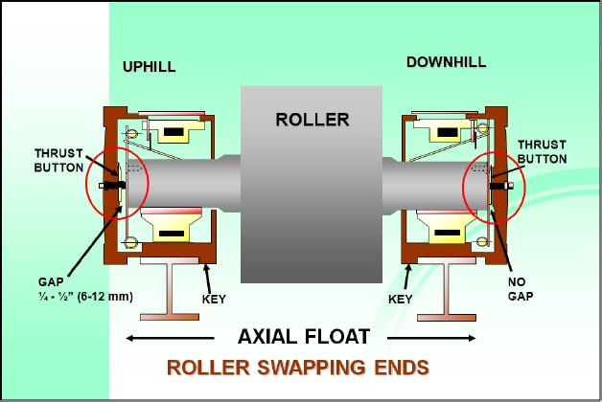
DETERMINNG THRUST DIRECTION BY ROLLER POSITION ( Type I Housing )
Both uphill and downhill bearing housing are keyed into the bases such that the space between the thrust buttons is ¼ - ½” or 6 – 12 mm larger than the length of the shaft. This, allows the roller to have that much axial float. When the roller is skewed to drive the shell slightly uphill, its reaction is to slide downhill. The normal and expected position for all the rollers is to be in contact with the downhill thrust button.
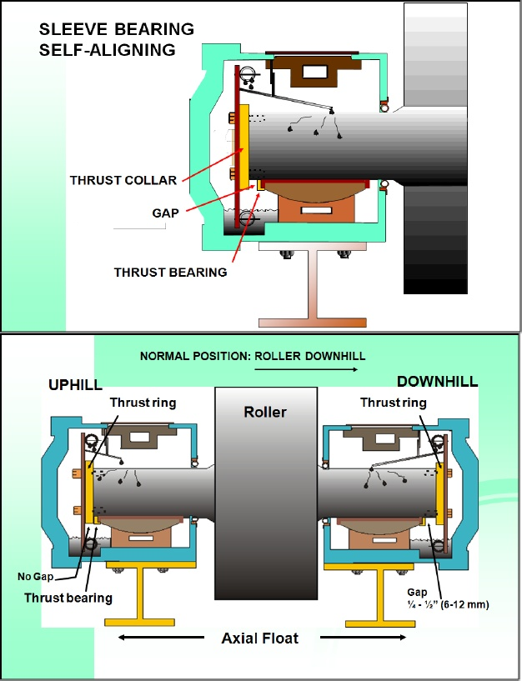
Type II.) Sleeve Bearing, Self-Aligning with Thrust Collars on the Shaft
The thrust collars are located on the ends of the shaft or on the shoulder of the shaft near the roller. Visual inspection through the inspection ports of the housing allows us to locate the gap. This is the gap between the thrust collars and the thrust bearing.
With the thrust arrangement as shown above, the normal expectation is to have the gap on the downhill end of the shaft. This indicates the roller is positioned downhill and is pushing the shell uphill.
DETERMINING THRUST DIRECTION BY ROLLER POSITION ( Type II Housing )
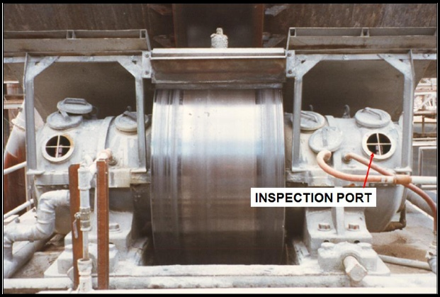
The normal and expected position of all the rollers, if slightly skewed to push the shell uphill, is to position itself downhill. With Type II style bearing we then expect to see no gap on the uphill side and a ¼ - ½ “ or 6 – 12 mm gap on the downhill side. Tapping the end covers on this style of bearing housing does not tell us anything.
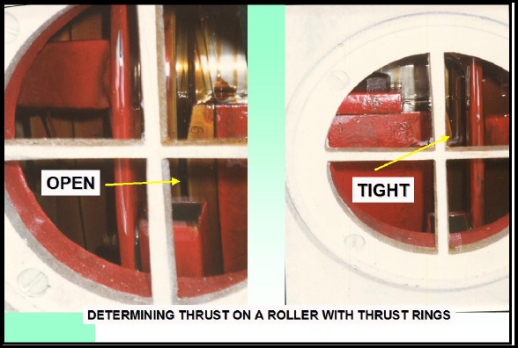
Determining thrust on Type II style housing is a matter of removing the inspection port and examining the position of the roller. When the ports are removed you will see ( below ) where one washer is tight by noticing that oil has been wiped clean from its surface. This can only be see on the roller on the down turning side of the shell. The other should show a gap in which the oil runs freely over the thrust washer. This type of roller is considered a “ puller”. This means that the shaft will move until it seats against the thrust collar.
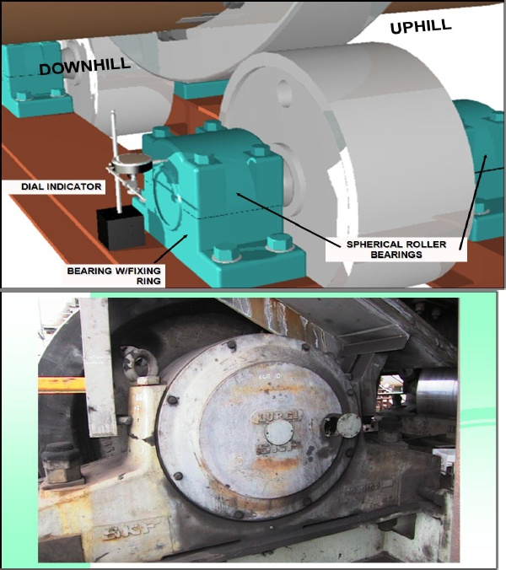
Type III.) Spherical Roller Bearings ( No separate thrust bearings )
This is the most difficult type of bearing to deal with for setting skew. The previous style of bearings is specifically designed to utilize the “ action- reaction “ phenomenon of skew by allowing room for a small amount of axial shift. That ¼ - ½” or 6-12 mm float is essential for setting skew correctly. With spherical roller bearings are mostly installed on smaller faster- turning units. Faster turning means a proportionately higher thrust for any given skew. Unfortunately these bearings have a low tolerance for thrust load. Consequently we see a much higher failure rate with spherical roller bearings as compared to Type I and Type II bearings.
Type III.) Spherical Roller Bearings ( No separate thrust bearings)
By fixing a dial indicator as shown, thrust load may be detected if the unit can be reversed. Often there is roll – back when a unit is stopped. Any thrust load will tend to tip the bearing housing slightly. Upon roll – back the thrust reverses direction. There will be a small amount of axial movement on the bearing housing. The greater the thrust load, the greater the amount of movement. Usually the fixing ring is mounted on the downhill side bearing. This then should be the housing to which the dial indicator is mounted. If it is mounted on the other bearing, the “ free” bearing, then the outer race may move within the housing and the movement may not be detected by the indicator is mounted. if reversal is not an option, then slapping a broom handle wrapped with a greased terry cloth across the face of the roller will also do the trick. As the strip of grease goes through the pinch point, the thrust is relieved and the bearing housing jumps. This technique is obviously limited to a one time use.
Loosening the hold down bolts may be another possibility to release some axial movement on the housing. Safety is always a consideration to be heeded.
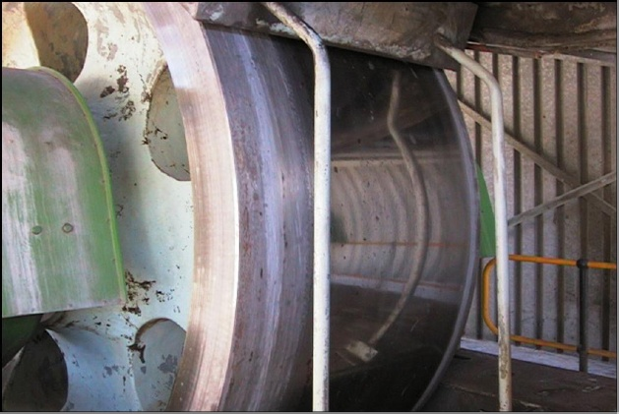
First a Visual Check
Determining roller position, uphill or downhill is only the first step. We also want to know how much each roller is skewed. Let’s look at the surface of the roller.
A well adjusted roller, one with a minimum amount of skew, close to neutral, will look very polished. Its surface will be mirror like, almost chrome plated in appearance and be very reflective. A poorly adjusted roller with excessive skew will appear dull and gray by comparison. In the extreme it will be very rough and have tiny flakes of material coming off its surface.
Then the Wipe Test
Take a cotton rag, wipe across the face of the roller. First wipe from the discharge end towards the feed end. Then wipe the opposite way. On the roller with a dull surface there will be a distinct roughness in one direction, the fibers of the cloth almost seem to catch on the grain. The other direction will seem much smoother and the cloth will not hang up on the grain. On a shiny roller this difference will be imperceptible. By wiping all the rollers it will be easy to judge which is the roughest and which are the smoothest.
Any detectable roughness should be in the direction from discharge to feed end. That means the roller is pushing the shell uphill. Roughness feed –end to discharge-end means the roller is reversed skew, pushing the kiln downhill.
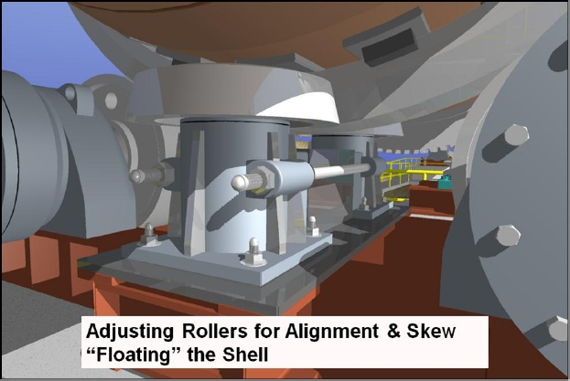
What does it mean to “ float the shell “ ?
When the shell rotates such that the downhill thrust roller is only engaged for a partial revolution and all the rollers are correctly skewed, then we can say the shell is floating. The thrust tire will always have a slight amount of wobble. While the thrust roller is in contact this cause the kiln to be pushed uphill for part of the rotation. As the wobble then moves always from contact with the thrust roller, the kiln moves gently downhill for that part of the rotation. The cycle then repeats.
What is “ correctly skewed”?
Each roller is pushing the kiln uphill and with a minimum amount of thrust.
This minimum is defined by the condition above. The combined thrust of all the rollers does not quite match the downward push of the kiln. In this way the kiln will slowly and gently move down but then be nudged back up by the wobbling thrust tire.
4.5 EMERGENCY COOLING METHODS
A. GRAPHITE
B. FANS/COMPRESSED AIR
C. WATER/ WET BURLAP
D. RADIATOR
E. SYNTHETIC OIL
If there is a history of hot bearings or if problems are anticipated for whatever reasons are prepared to deal with the situation of hot bearing. For units with sleeve bearing if a problem arises as a result of roller adjustments hot bearings are usually the first in the list. Be prepared.
The problem is either excessive thrust where the thrust bearing heats up or more usual there are grooves in the bearing shaft or brass sleeve which prevent smooth axial float.
If there is excessive thrust graphite powder can be applied liberally to the roller face. This will relieve all thrust and may allow the trunnion to cool. The graphite must be continuously applied until counteracted moves can be made, and the trunnion can be put into a position where it will run cool.
If thrust is not the issue then using a combination of fans and compressed air, cooler air can be directed at the bearing housing, roller, and trunnion shaft. Caution needs to be used so that dirt and other foreign material does not enter the inside of the housing. Do not blow air into the housing through the inspection port. This may cause an explosion.
It is not recommended that water be run directly on the trunnion face. Wet burlap on the housing will help cooling. Make sure water is flowing freely through the cooling jackets. Liberal application of water externally is good as long as it does not get into the housing at seals or inspection ports.
Usually the best method of cooling is to use radiator oil cooler. Using a small pump, a barrel of water, some lightweight, flexible tubing such as copper, and the proper fittings, a radiator can be fashioned to continuously cool the bearing oil. The suction side of the pump is connected to the oil drain on the trunnion. The oil is routed through the pump and into the coils of tubing submerged in a barrel of water. New cold water is constantly being run into the barrel to keep the exchange of heat as high as possible. The oil is then dispensed onto the top of the trunnion shaft through the inspection port. If desired, an oil filter can be connected into this system to filter out some of the particulate. Caution must be used to keep the filter as free-flowing as possible.
If a bearing is known to be problem synthetic oil should be used before any moves are attempted. Synthetic oil retains its viscosity to 450ºF ( 230ºC). if a petroleum oil is being used be prepared for the possibility of having to change oil “ on the fly “ to a synthetic to sustain a high rise in temperature. Some synthetic oil are not compatible with petroleum oils. The changeover must be total without cross contamination. Continue flushing with synthetic until the change is complete.
If none of these methods bring the temperature under control, bearing failure is imminent. Prepare to slow or stop the kiln. A slowed kiln may allow the problem bearing to “ seat – in”
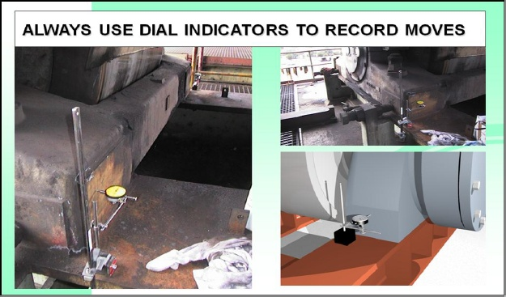
Moves can be properly measured using dial indicators, one for each bearing assembly. Often the magnetic bases for the radial indicators are inadequate to hold the indicator reliably over the course of an adjustment campaign. Weld brackets to the base and use clamps to hold the indicators for 100% reliability.
Adjustments using the “ flats” of the adjustment screw is good enough for “ ball park “ adjustment but must never be relied on for recording the actual moves made.
The bearing housing may take some time to seat in. leave indicators in place for as long as 24 hours after the last adjustment, before recording the final bearing position.
From our previous inspection we have catalogued roller position, surface conditions, thrust direction and what problem bearings ( if any ) exist. From this we can derive the most offending roller to the least, and sequence our adjustment campaign accordingly.
Suppose we were required to do more than set the rollers to their correct and minimum thrust. Suppose it was required to move them for alignment and skew as well. Say our first roller needs a 15 mm ( 0.6” ) move towards the center line of the unit in order to correct for alignment. This would then be an alignment adjustment. We will use the roller reaction to guide our work.
The first move would be a small one of about 0.5 mm ( 0.020” ) in one bearing. The bearing first moved would be the one which would bring the roller closer to neutral. Wait about 20 minutes until the roller has had a chance to shift. This is also enough time to catch any temperature rise in the bearing/oil sump. Record all temperatures again. Trouble can be identified be a temperature rise anywhere, not just in the bearing being moved. Assuming that the shaft journal and bearings are in normal condition and no temperature rise was encountered, these steps would be repeated as necessary until the roller shifts position. The roller’s shifting position indicates that the neutral point has been crossed. This is the most critical aspect of the whole procedure: to get the roller to shift position without any significant temperature rise in any of the bearings.
Once it is seen that the roller shifts easily without a temperature rise, then the size of the moves can be increased to say 2 mm ( 0.80” ) per bearing. The sequence of the moves should alternate from one bearing to the other with the shaft sliding across with each move. Waiting 20 minutes between moves is also unnecessary as long as the shaft shift easily with each move. The work can continue smartly providing there are no other mitigating circumstances like a bowed shell, etc. this continues until the average of the moves for both bearings reaches the desired total, 15 mm for this example. The final moves should be very small ones to leave the minimum amount of skew on the roller.
Even the largest rollers, and there are some as large as 10 feet ( 3050 mm ) in diameter, will respon quickly to a 0.10 mm ( 0.004” ) skew adjustment. Naturally all the work must be monitored with dial indicators and must be done with the unit in operation.
4.6 ROLLER ADJUSTMENTS
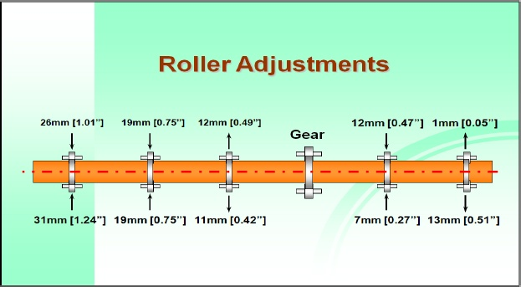
This procedure is used with units that have sleeved bearing. See “ Two- Pier Alignment “ for the procedure using spherical roller bearings and pillow blocks. The principle of roller reaction is always valid even though thrust direction is not seen by axial roller shift. Secondary techniques need to be used.
This is not desirable.
Toed-in rollers can balance each other, one pushing the tire down as hard as the other is pushing it up. If situation exist the shell may be “ floating “. Floating means that the shell is balanced between thrust rollers. But it is not the desired situation.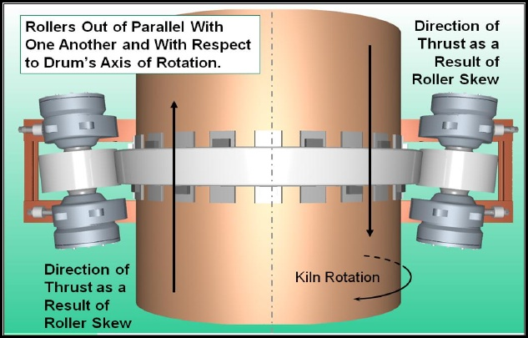
Left uncorrected there is unnecessary wear and tear on the whole support.
Left for long periods of time the tires and rollers will wear into a cone shape.
How do you quickly identify if a roller is skewed?
Look at the surface. A roller with little or no skew will polish up to a mirror finish. If the surface is dull and gray and appears rough, then skew is present and probably excessive.
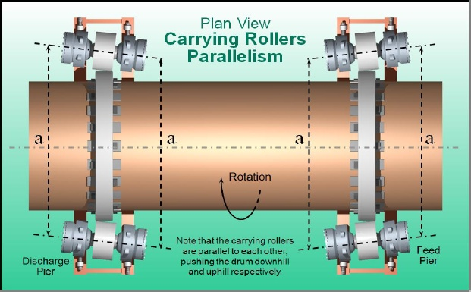
This is also not desirable
Rollers should be parallel to each other, set in the same direction on all piers. Often measuring between bearings or shafts, as “a” above, may reveal that they are parallel and not toed – in as in our previous example. Unless these measurements are tied into a common reference line, the above situation will not be identified.
Once again this situation could be present with the shell “ floating “. Assuming from that observation alone that all is well, will lead to excessive wear and tear of all the support components. Careful inspection using the simple techniques already described will show this immediately.
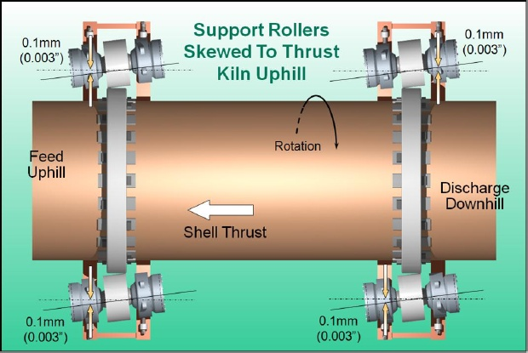
Ideal Placement.
Unfortunately many designs require that support rollers be skewed. The thrust mechanisms of these designs are inadequate to support the entire downward thrust of the shell. This is especially true of large long rotary kilns. Since most of this type of rotary trunnion-supported equipment is installed on a slope, there is a natural component of force acting in the axial direction of the shell. If this force cannot be completely managed by the thrust mechanism(s) it is the skewing of the support rollers that must help out.
Skewing is a compromise. Skewing accelerates the wear and tear of the support mechanisms but then allows smaller, less costly thrust mechanisms to operate successfully. If skewing is insufficient the thrust mechanisms will fail prematurely. If skewing is excessive additional wear and tear of the support components takes place and the thrust mechanism can still fail. If rollers are skewed against each other, wear and tear takes place but the advantage supposedly gained by skewing is lost.
The maximum performance life of rotary equipment that requires skewing, can only be achieved by skewing correctly and keeping it to a minimum.
The amount of skew shown in the illustration may be sufficient for most installations.
BENEFITS OF PROPER THRUST
- REDUCED WEAR RATE.
- REDUCED STRESS ON TIRE
- REDUCED ELECTRICITY CONSUMPTION.
OTHER CONDITIONS EFFECTING THRUST CONTROL
- LOAD
- OPERATING TEMPERATURE
- AMBIENT CONDITIONS
- SPEED
- LUBRICATION


5.1 INTRODUCTION
A rotary kiln is lined with bricks designed to withstand the tremendous heat that is generated inside the kiln shell, and the mechanical stress that are present during the countless rotations of the shell. Bricks can be made from a variety of materials, and are chosen for their ability to protect the shell, for their durability, and their ability to maintain the heat necessary for the process which goes on inside the kiln.
The lining bricks are wedge-shaped or tapered, designed to fit the curvature of the shell. If you look inside a kiln shell you will see thousands of bricks, laid up in rows around the circumference of the shell.
There are several methods of installation, including the screw-jack method and laying the bricks with mortar. The method chosen should suit the type and size of kiln being used, and of course, should follow be recommendations of the refractory specialist.
In this section we will look at what happens to brick linings over a period of time and why linings fail. The bricks offer many clues that can help identify the probable causes for refractory failure and may help you determine a plan of action.
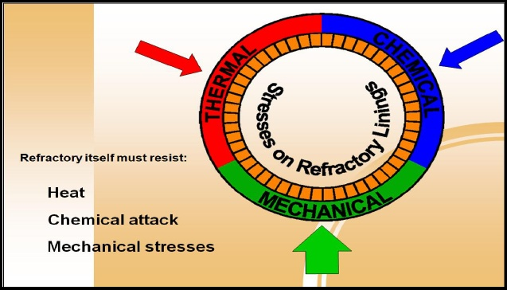
This section will not discuss how to choose bricks. The choose as to what brick grades are suitable for the individual zones in a rotary kiln depends on the process and the location within the kiln. Each kiln will have unique requirements. This can best be determined by the refractory specialist that visits your plant regularly and becomes familiar with each kiln’s operating characteristics.
There is a lot to be learned be examining an old brick lining.
5.2 STRESSES ON REFRACTORY LININGS
In the first part of the seminar we have discussed some aspects of mechanical stress and how they affect the steel kiln shell, rollers and tire. We have also discussed how temperature fluctuations affect a kiln shell. These stress affect all components of a unit including the refractory lining. There are three basic stresses acting on the refractory:
Mechanical – resulting from the shell flexing due to ovality and kiln misalignment
Thermal – heat load and possible thermal shock
Chemical – reactions through heat and the chemical composition of the raw material and fuel.
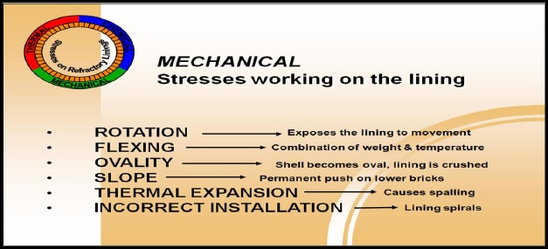
These requirements want contradictory physical properties in the refractory. Good thermal characteristics come at the expense of mechanical resistance. Good mechanical resistance makes ppor insulators. Chemical resistance properties, like glass for example, also make for either a poor or are weak to resist bending stress. The ideal brick is often thought of as one made of a chemical and heat resistant rubber! An absurd idea but it does highlight the challenge of refractory design. For this reason different refractory materials are formulated to fit different circumstances. Selection of refractory is consequently extremely important to ensure that materials are matched as best as possible to the requirements of the application.
5.3 OVERVIEW – MECHANICAL STRESS
CONTINUOUS ROTATION – Even when the bricks are installed correctly, continuous rotation means movement. If the bricks are incorrectly installed, they can shift and twist causing stability problems not only to the lining but through abrasion, may damage the shell itself.
FLEXING- A shell can be several hundred feet long and as large as 25’ in diameter. It is only supported at several locations along that length. Rotation causes it to flex, which in turn stress the brick lining.
OVALITY – Due to the weight of the load, the weight of the bricks and the weight of the shell itself. If the tire does not support the shell adequately to keep it nearly perfectly round it becomes “ oval”, which has a crushing effect on the lining.
SLOPE- Bricks are “ pushed “ from the feed end to the discharge end by gravity and the pressure of the product being fed through the kiln. Bricks can be crushed against retaining rings.
EXPANSION & CONTRACTION – Bricks expand up to 30% more than steel. Usually the brick lining is fully expanded and compressed against the shell in the operating condition, but during a rainstorm or kiln upset, the equilibrium between the shell and lining is upset and the bricks may come under extreme pressure or the lining may become loose. Either extreme can cause a collapse!
INCORRECT INSTALLATION – A shifting lining, broken bricks or a collapsed lining are typical symptoms of a poor installation. Refractory installation in a kiln is not the same as it is in stationary furnaces, which comprise 90% of refractory installations. Ensure your refractory specialist is also a kiln specialist!

SPIRALING
If a new lining has twisted or spiraled it may be because of excessive rotation without sufficient heat to expanded and lock it in place. The lining could also migrating because of a loose installation. Frequent starts and stops with associated temperature fluctuations will also contribute to this problem.

OVALITY or “ SQUEEZE & RELEASE “
Compression crushes refractory by shearing or capping the hot brick face, which usually occurs randomly in the tire area.
Crushed or capped bricks as seen here, when the affected area is at or near a tire, is a symptom of failure due to excessive ovality. OVALITY is defined as the change of curvature of the shell plate caused by normal rotation. This is easy to understand when you consider that every brick undergoes at least two cycles of compression and one of relaxation on every revolution.
The flexing shell concentrates stress on the refractory hot face and when it becomes excessive the brick caps shear off.
5.4 SLOPE
BRICKS COLLAPSE AGAINST RETAINING RINGS
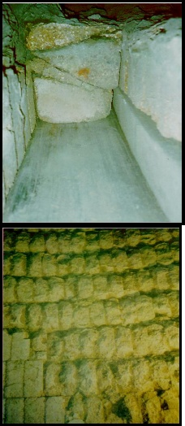
Kiln piers are sloped from the feed end to the discharge end to allow the process material to move from end to end. Even though the slope is not large. 2 -4%, it is enough to push the bricks toward the discharge end. Retaining rings, welded to the steel shell, are sometimes used to prevent this from happening but the bricks can press against the steel rings and be crushed.
The retaining ring is installed a short distance- equal a few brick ring widths – from the outlet of the kiln. If another ring is installed further up the kiln ( not in the discharge area ) it should not be located in the vicinity of a tire.
THERMAL EXPANSION
“ Cobble stoning “ : convex spalling in the bricks
During thermal expansion excessive axial pressure may be produced which the brick is not strong enough to withstand. Spalling on the recommendations of your refractory specialist, this condition can be remedied by placing cardboard spacers or a thin mortar layer between the bricks.
5.5 THERMAL STRESS
Concave Melting Pits
Overheated brick sometimes called “ duck – nesting “
CONCAVE MELTING PITS
Standard – grade bricks that have no coating build up and are overheated are weakened and look melted. This usually is the result of the flame hitting the lining directly. Adjustment of the burner eliminates this problem. The flame envelope is around 3000F and no refractory can withstand direct flame impingement.
THERMAL
Heat effects working on the lining
- OVERHEATING OF BRICKS – wash out or “ duck nesting “
- Overheating of clinker –DENSIFICATION OF THE HOT FACE
- Excessive thermal load- CAUSE STRUCTURAL FATIGUE OF BRICKS
- Thermal shock – thermal tensions cause horizontal cracks
OVERHEATING OF BRICK weakens the brick structure of the hot face. You will see concave wear, so – called “ duck- nesting “. This situation can be caused by poor choice of refractory for the process and or flame impingement on the lining.
OVERHEARTING OF CLINKER changes the mechanical properties of the bricks and cause densification at the hot face. Symptoms include lava – like coating solidly connected with the bricks, and falling coating which will take off the densified brick heads. This phenomenon is caused by the formation of an increased liquid clinker phase infiltrating the hot face.
EXCESSIVE THERMAL LOAD generally occurs during overheating above 1700ºC without a liquid phase. This will cause structural fatigue of the bricks. The grain of the brick matrix will look like brittle needles instead of a round grain.
THERMAL SHOCK is caused during sudden temperature changes. This generally occurs during quick heat-up or sudden cool – down. Coating loss cal also cause this problem. He bricks will spall in layers.

The question Is always, do we bring the kiln down for a longer period of time and replace the whole burn zone and transition area, or do we just patch a small area and get up and going again more quickly. The answer of course depends on prevailing condition.
PATCH & GO – Making small repairs throughout the year requires several cooling’s and heating’s of the kiln. This, as we have seen, is hard on the kiln, causing bricks to spall. It also adds lost production tome and increased fuel costs. This method is generally used only after trouble develops, such as a “ hot spot “ in the shell.
5.6 SCHEDULED MAINTENANCE
In this approach most of the lining is removed and replaced. Even if the bricks seem to have good thickness, they have probably beeb compromised mechanically or chemically, and will probably not last until the next scheduled maintenance. A rule- of – thumb for most plants is to replace anything that is 50% less than the original lining thickness.
It is a good idea to document the replacement job. Take a physical count of how many bricks were used and what shapes they were. Evaluate the refractory specialists that did the job and make notes of any problems that arose so they can be avoided next time. Remember that if the kiln shell is deformed, whether from previous hot spots or excessive ovality, this will affect the quality of the new refractory work is done.


No discussion of troubleshooting kilns, dryers, and other rotary equipment would be complete without the inclusion of the special problem of gears, pinions, and drive trains. Understanding the mechanical function of these parts and the differences in their design will help to focus on area that may cause problems in the future, or may already be causing problems.
The alignment and mesh of the gear and pinion, the lubrication that is used, and the other components involved in the drive train, are all areas that should be carefully inspected on a regular schedule.
Covered in this section are the two most common types of gear mounting arrangements, their pros and cons, and a recommended inspection program.
Characteristics, advantages and disadvantages of different types of lubrication are discussed as well.
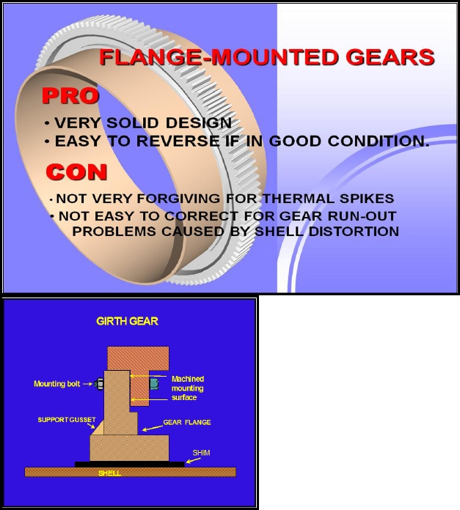

6.1 FLANGE – MOUNTED GEARS are found on older kilns or on equipment such as dryers and coolers that operate in a lower temperature range. They are generally constructed in 2 to 6 sections, and the mounting flange is typically welded directly to the shell. It is easy to reverse the gear to maximize service life if the flange is still rotating true and in good condition. However, a common problem encountered when attempting to reverse or install a new flange – mounted gear is that over time the shell has incurred thermal damage because of refractory failures.
Depending upon the location of this damage, it can create a significant amount of run out.
In the shell where the gear is mounted. If this is the case, the mounting flange must be cut loose and remounted or a new flange must be installed.
In some cases additional centering of the gear can be accomplished by redrilling the mounting holes in either the gear or the flange. This can also be limited by the way the flange was originally machined.
A careful inspection should be made for these factors and consideration given prior to planning any gear reversal projects.
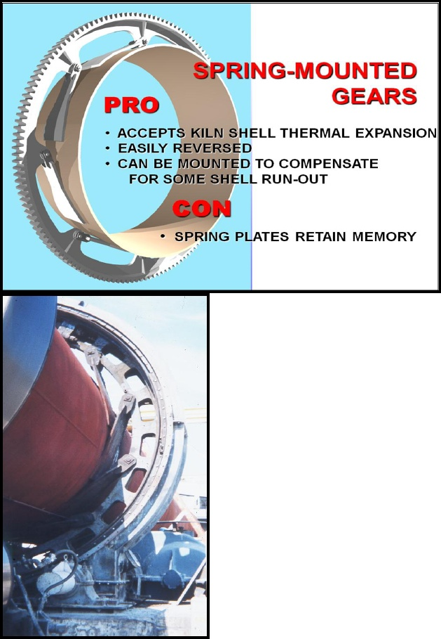
6.2 SPRING – MOUNTED GEARS are the predominant type of girth gear arrangement for kilns. There are two basic variations, the most common, the tangential spring, and the horizontal spring bar. The positive aspect of these designs is that they allow the kiln shell to expand without restriction, unlike the flange-mounted gear.
When installing a new gear or reversing an existing gear, it is always advisable to replace the spring plates and the pins. The plates are subjected to thousands of cycles over the years and as such there is always concern for fatigue failure. Also, since the springs are welded to the shell, they are usually compromised to some degree during the removal process. Trying to reuse the spring plates can greatly inhibit the ability to achieve acceptable gear run – outs.
6.3 REGULAR VISUAL INSPECTION
Add life to your gears through regular inspection. Establish a check list for systematic inspections daily, monthly and annually. The following areas are critical elements of good gear maintenance.
Mesh – proper backlash and root clearance are critical to smooth gear operation. Too much or too little clearance can cause problems that contribute to accelerated wear and loss of tooth profile. Also important is the longitudinal relationship of the gear relative to the pinion.
contact – The contact pattern across the tooth face is a telltale sign of gear alignment. If an axial run out condition exists, the contact pattern will vary with the rotation of the kiln. Angular misalignment between the gear and pinion result in partial tooth contact, concentrated loads and premature gear wear or failure.
Reducer condition – inspect for vibration and elevated temperatures of the reducer.
These are usually signs of worn bearings or gears, or a lubricant problem.
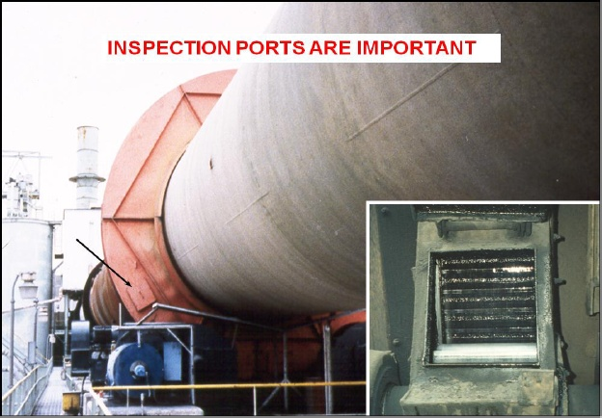
Inspection ports - it is important to have observation ports in the gear enclosure to allow for adequate inspection of the gear teeth. There should be ports on both sides of the enclosure to allow inspection of the depth of the mesh on both sides of the gear, and a port in the area above the pinion to allow inspection of the contact pattern across the teeth, just after the gear teeth are released from the pinion. 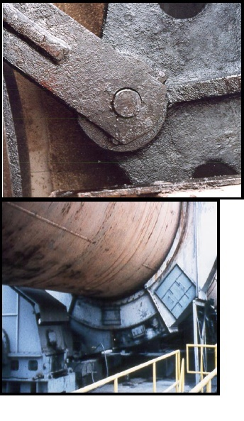
Drive base condition – The base should be anchored firmly to prevent vibration and movement of the drive components.
Condition of the surrounding area – Housekeeping can be a major factor in maintenance and upkeep. If there is product buildup and lubricant leaking or spilled around the drive pier, safety can become a “ big” issue for the technicians who are trying to inspect and maintain the equipment. With today’s tight environmental restrictions, spilled lubricant can also become an environmental problem.
On a spring- mounted gear, the hole where the spring plate attaches to the gear is called the “ boss hole”. Inspect the boss holes and the pivot pins for any sign of wear or excessive movement.
Most girth gears are a two- piece segmented style. This means that the splice bolts will also need to be checked to make sure they remain tight.
Areas, boss pins and splice joints should be observed as they pass across the pinion. In this area the gear is in tension before it comes into pinion mesh and in compression after the mesh. This change of load tension to compression will be visible if there is any looseness of fit in in the pins or bolt in the splices. Lubricant should be present in both areas and movement can be detected as the lubricant is squeezed or sucked into/ out of the joint.
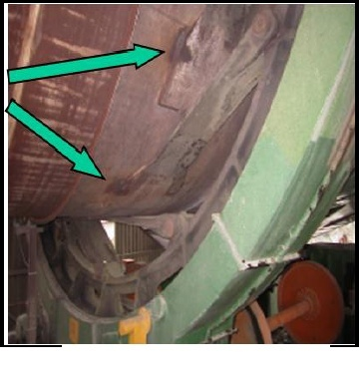
6.4 DAILY / MONTHLY
A. Visual inspections

B. Listen for unusual noises.

C. Is kiln against uphill/downhill thrust roller?

D. Condition of drive system?

E. Welds, mounting & splice bolt?

F. Tooth engagement/ mesh

G. Tooth profile wear

H. Vibration?
Figure 14: welds on spring plates

Noise – Listen for any unusual noise and try to find the source. A common problem that can cause a squealing or thumping noise is the gear rubbing against the side of the enclosure. When the kiln shifts longitudinally and there is excessive clearance between the side face of the thrust tire and its retaining blocks or between the thrust tire and the thrust rollers, the kiln can move too far longitudinally allowing the gear to interfere with the enclosure. As part of your inspection always make a note of the position of the kiln with respect to the thrust rollers, the location of the thrust tire between its retaining blocks and the axial position of the gear with respect to the pinion.
Condition of the drive system – Monitor the condition of the gear reducer and the pinion support bearings. Elevated temperature or a high frequency vibration or chatter is an indication of a bearing problem. This could be either the pinion support by using vibration analysis equipment can help pinpoint the source.
Welds – On spring- mounted gears, check the welds attaching the spring plates to the shell. On flange- mounted gears inspect the welds between the shell and flange. These are both highly stressed areas subjected to cyclical loading and therefore susceptible to fatigue cracking. Keep welds 1” (25mm) back of the tangent point.
Mounting and splices – Visually inspect for loose or missing mounting bolt on a flange- mounted gear. On a spring-mounted gear, the hole where the spring plate attaches to the gear is called the “ boss –hole “. Inspect the boss holes and the pivot pins for any sign of wear or excessive movement. Most girth gears are a two-piece segmented style. This means that the splice bolts will also need to be checked to make sure they remain tight.
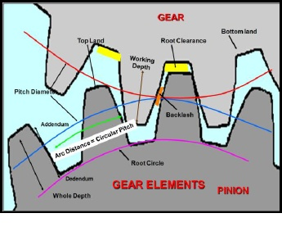
The kiln will not generally be shut down to allow for physical testing or inspection of the bolts and welds. Therefore you must learn to look for signs that indicate potential problems. A simple way to look for loose bolts or cracked welds is to watch them as they pass across the pinion. The gear is loaded in tension as it approaches the pinion and switches to compression as it disengages the pinion. Normally, everything is covered with lubricant and any movement such as a loose bolt or cracked weld will result in “ squishing” or “bubbling” of lubricant as this load cycling occurs. If these signs are obvious, further physical examination is warranted during the next outage.
Tooth engagement –Most gears are manufactured with pitch lines scribed on both sides. Under ideal conditions the pitch lines should be lined up or slightly separated during hot running condition. If the pitch lines are visible, watching them as the kiln rotates can give you an indication of radial run out and mesh condition. Unfortunately this is seldom the case. Lubrication can make the pitch lines difficult, if not impossible, to see. Or, if the gear has at some point rubbed against the enclosure the scribe lines are most likely worn away.
Another method of determining proper tooth engagement is to measure the backlash, or the amount of clearance at the pitch line between the tooth space and the corresponding tooth width. This measurement is only useful with new gears. Once the gear teeth exhibit any signs of wear this measurement is no longer valid. In many cases, a more reliable method of checking proper tooth engagement is by observing the root clearance of the gear teeth throughout the rotation. It is important to note, that while looking for root clearances, you must also look closely for a worn tooth profile that could cause “ false bottoming”. As a general rule of thumb, the hot operating root clearance on most kilns should be approximately 5/16. This is based on the common 1 DP or 3” CP gearing. It is very important to know you’re gearing so that actual clearances can be determined.
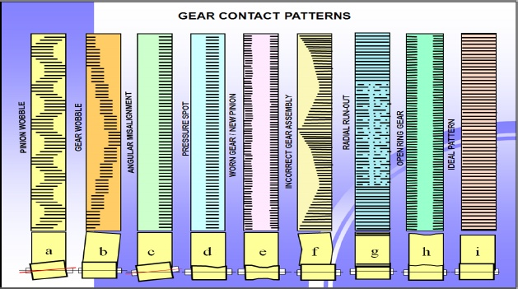

CONTACT PATTERNS DUE TO ASSEMBLY FAULTS OR OPERATIONAL CONDITIONS.
- Pinion is running out ( wobbling ). Check fixation of pinion / shaft
- Ring gear is wobbling. Assembling and adjustment of ring gear must be checked.
- Edge pressure. Pinion must be realigned axially or slope corrected.
- Pressure spot on total circumference ring gear. Manufacturing fault or new pinion wearing into existing wear pattern of ring gear.
- Pinion diameter enlarged on both sides due to wrong assembling or ring clamping devices.
- Ring gear joints and fixation of both ring gear sections must be checked.
- Radial run – out of ring gear. The picture of contact is stronger over one half of the circumference. Radial readjustment is necessary.
- The ring gear has opened on both sides due to thermal expansion.
- Ideal pattern
6.5 VIBRATION
Check to see that the gear are running with proper root clearance or backlash. Too little clearance will cause gear teeth to “jam” together as they mesh causing a vibration problem as the top land of the tooth “pounds” into the bottom land. If you observe a vibration that is intermittent, check first for interference on either end of the kiln end of the gear enclosure. If there are no signs of any rubbing, it is most likely that the shell has a bend that is causing the gear to run out. If this is the case, the vibration will be in a direct relationship with the shell warp. As the bent area of the shell passes across the pinion, the vibration can be felt as the gear teeth “ bottom out”. If the vibration is constant throughout the entire rotation, the kiln is acceptably straight but the contact surfaces of the riding rings, support rollers of filler bars have worn enough to lower the kiln to a point of interference of the gear mesh.
Too much clearance creates excessive backlash, which under certain condition also causes a vibration problem. If there is a severe bend in the shell, even though it is not an area that cause gear run out, or perhaps a large uneven buildup of product coating, an unbalanced load is created in the kiln. As the heavy side of the gear will try to “ overrun “ the pinion. If excessive backlash exists, intermittent vibration will appear at a frequency equal to gear tooth engagement frequency.
Careful visual inspection of the gear for these condition can help determine the cause and then a solution to vibration problem. Usually a stroboscope must be used for the inspection, and you will need to pay close attention to the occurrence and duration of the vibration with respect to the gear mesh. A temporary clamp on current probe can also be used on the drive motor to evaluate an intermittent vibration problem. Typically if the motor current reads high during the vibration phase, the unit is straining to lift the heavy zone of the kiln which is causing gear run out and a resultant “ bottoming” condition. Conversely, if the motor current is low during the vibration phase, the motor is “ loafing” as the bend in the shell advances to the down- turning side and backlash allows the gear to “over run “ the pinion.
6.6 ANNUALLY
A. Clean & measure amount of wear to teeth.
B. Fix leaking seals.
C. Check teeth for abnormal wear.
D. Change gear lubrication.
E. Clean bottom of gear guard.
During the annual inspection, since the kiln will be shut down, more thorough inspections should be made of the gear wear patterns. Remove a portion of the gear enclosure and with solvents, clean a 1-2 foot long are of the gear teeth. Measure the tooth thickness on both the uphill and downhill edge and make note of the type of wear pattern. Rotate the kiln and repeat this process in 4-6 other area. Look for ridges “ or steps” in the tooth profile. In some cases, if they are not too severe, these areas can be ground down with a small hand grinder. This inspection should give you a good indication of how the pinion has been meshing with the gear and if there is excessive run out.
Gear lubrication should be changes out taking extra care to remove all spent lubrication in the bottom of the enclosure. This is the area where most of the contamination will settle.
inspect the labyrinth seal of the enclosure for signs of wear. Fix the seal and any holes in the enclosure as necessary. Keeping the enclosure in good condition will help minimize dust and other contaminants from getting into the lubricant. Lubrication contamination is one of the major causes of wear.
If the inspection of wear patterns indicates a run out problem, check both the axial and radial run out. These measurements can only be taken while the kiln is shut down. Also, if warranted, check the slope of the pinion. If any adjustments or shimming of the pinion bearing are required, realign the balance of the drive components and couplings.
6.7 AXIAL RUN OUT
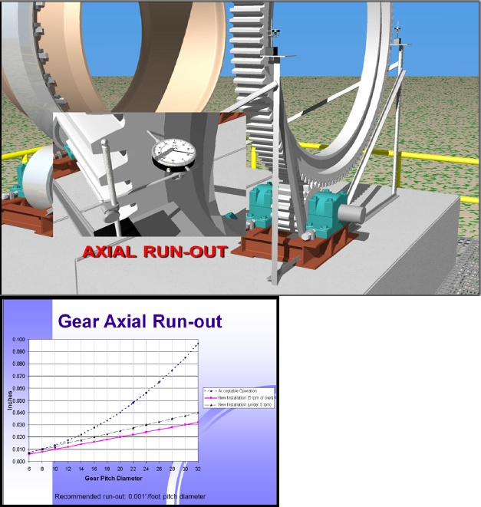

Axial run out occurs when a gear “ wobbles” from side to side as it rotates. Some side-to-side movement is inherent in the design of rotary equipment, however, the tolerances are small. Excessive axial run out will wear gear teeth unevenly, cause uneven pressure on the pinion, and will magnify other problems that the unit may have.
When correcting gear run-outs, the axial run out is generally corrected first. It should always be measured using two dial indicators 180º apart, usually at the horizontal center line of the gear. This stands used for the dial indicators must be rigid so as not to “ sway” and give false readings.
The gear should be divided into 12 equally spaced segments and the side rim of the gear should be cleaned in these areas. As the kiln is slowly rotated, readings are taken on both indicators. The readings directly opposite each other are then mathematically averaged to find the amount of “ wobble” in the gear.
The reason for using two indicators is to negate any axial float of the kiln and any “ wobble” of the thrust rollers.
Illustrated on the chart above are typical curves for the amount of acceptable axial run out of girth gears for kilns and similar roller-supported machines.
The allowable axial run out is a function of the gear diameter. For the most part, gear manufactures and OEMs of rotary equipment recommend 0.001” of axial run out per foot of pitch diameter. This rule applies to new installations, and to gears running at 5 rpm and over.
Another level of tolerances is show for new installations with gears running at less than 5 rpm. This is generally a 25% additional run out allowance.
The “ acceptable tolerances “ should be applied to installations where the unit has been heated and expansion has taken place, or wear is present. In this case, it is unlikely that original tolerances can be attained.
This is just a guide. Values specific for any particular gear should be obtained from the gear manufacturer.
6.8 RADIAL RUN OUT
Gear run out measurements are used to set the gear originally and can be used anytime thereafter to check alignment.
Radial run out occurs when the axis of rotation of the gear changes as the kiln rotates.
Some slight change can be expected, but if measurements are taken and show a large variance, corrective action should be initiated. If the gear is accessible through the inspection port, a dial indicator should be place on a 2”x2” angle-iron tripod at the appropriate position. If this is not possible, part of the enclosure will need to be removed to provide access.
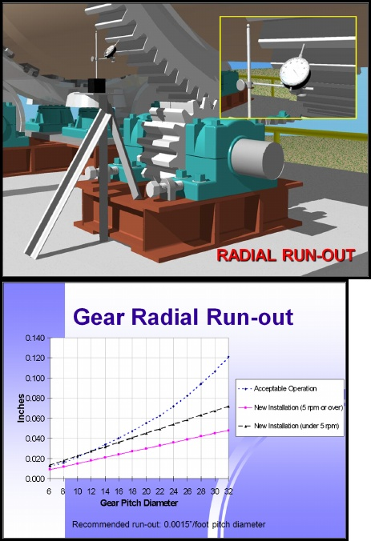
Measurement of radial run out is done by dial indicator. Twelve teeth, equally spaced and numbered around the circumference, that is every 30º, should have their top faces cleaned. The gear is slowly rotated. While the gear is moving the indicator stem is held back. The gear is stopped at each of the twelve teeth and an indicator reading is recorded.
A rigid setup is required for the dial indicator and extreme caution should be taken so as not to disturb the indicator placement during the procedure.
Taken the maximum reading and subtract the minimum reading. This is the radial run out. Compare this to the acceptable value for your gear. Values exceeding the acceptable values will reduce the service life of the gear set.
Illustrated in the chart above are typical curves for the allowable radial run out of girth gears for kilns and similar roller – supported equipment. The allowable radial run out is, as with axial run out allowances, a function of the gear diameter.
Gear manufacturers and OEMs of rotary equipment typically recommend 0.0015 of radial run out per foot of pitch diameter. This applies to new installations and to gears running at 5 rpm and over.
The level of tolerances shown for new installations with gear running at less than 5 rpm is calculated by adding an additional 50% to the run –out allowance.
The “acceptable tolerances” should be applied to installations that have been in use for a period of time. These are unlikely to attain the original tolerances.
This chart is just a guide. Values specific for any particular gear should be obtained from the gear manufacturer.
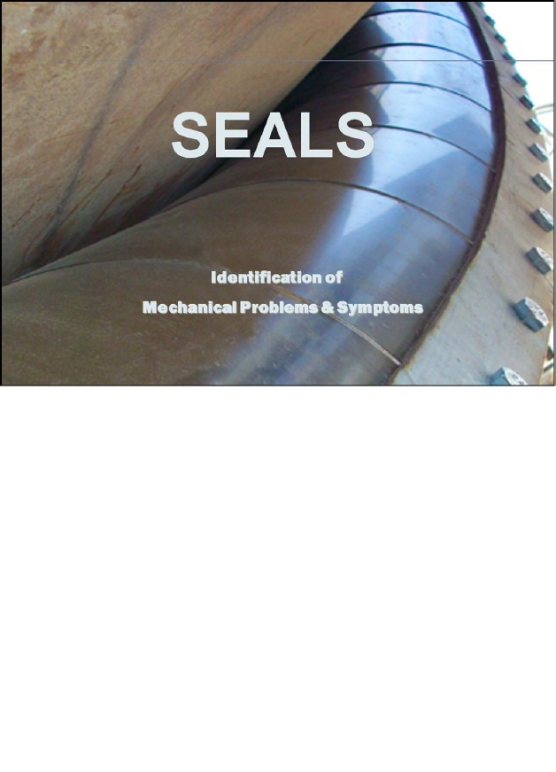
A seal is essential at each end to prevent ambient air from entering the process. Air leakage can have varying effects on different process. A leaky seal may reduce efficiency: create unsafe or unstable conditions.
Seals are damaged most by overheating or by physical abuse. Overheating can occur becase of insufficient cooling by fans or by insulating them from natural cooling. Physical damage is done by not cleaning seal discharge chute or by running the kiln to slow causing spillback.
Each seal is designed for the kiln diameter, maximum run out, temperature, and pressure that it need to isolate. There are many kinds of seal and each offer advantages in their application.
7.1 KILN INLET SEAL
The kiln inlet will be exposed to negative pressure to the magnitude of the about 20-25mmwg. Any false air ingress at the inlet end not only requirement of fan power and thermal energy. Therefore it is very important to arrest false air ingress bat kiln inlet end.
In the rotary kiln, raw material is fed through the inlet chamber from the inlet end gets discharged as the clinker into cooler the discharge hood. Both ends of kiln have fixed hoods, where rotating kiln ends protrude in to them, such intrusions in to fixed hoods leaves small gaps all around through which ingress of the false air take place. These gaps need to be closed by providing seals.
7.2 KILN OUTLET SEAL
The kiln normally runs at negative pressure and occasionally goes to positive pressure due to flame turbulence. The negative pressure cause false air ingress in kiln and positive pressure cause hot gases and product duct to escape from the kiln.
Therefore seal is provided to prevent air ingress into the kiln and control dust leakage in to the atmosphere.
The outlet seal exposed to negative pressure normally to the magnitude of about 1-3 mmwg. The ingress of false air disturbs the temperature profile and shape of the flame,. Therefore it is very important to arrest air ingress at kiln out let.
The various designs of seal are available. The inverted leaf design is most effective and efficient because of extremely flexible, rapid and easy maintenance. The leaves do not come in contact with escaping dust thereby avoiding abrasion of the leaves, which cause the damage. When kiln develops positive pressure. This sealing arrangement can be installed on any size and age of the kilns.
7.3 SEAL DESIGNS
A. Graphite Block Seal
B. Face Plate Seal
C. Outward Leaf Seal
D. Inverted Leaf Seal
Any discussion of drum end seal maintenance can be lengthy because of the wide variety of seal designs used over the years by various rotary equipment manufacturers. The designs are as simple as a piece of rubber belting or ceramic fiber blanket, or as elaborate as utilizing counterweights, pulleys and air cylinders in an attempt to create a more positive seal.
The primary purpose of any seal is to keep “ tramp” air out of the unit to allow better control of the process. A secondary but important function is to help control dust and hot gases from escaping from the kiln or dryer if there is some sort of “ upset” condition.
To be successful, the seal for a rotary kiln or dryer must accommodate both axial and radial movement. The major downfall of most seals is too many moving parts susceptible to “ sticking” or failure from dust contamination or heat distortion. The three main causes for seal failure are abrasion from product contamination, excessive shell run out in the seal are, and expansion and contraction of the unit during operation.
For the purpose of this discussion maintenance issues of four common types of seals will be reviewed. The four types are the graphite block seal, face plate type seals, the outward facing leaf seal and the inverted leaf seal.
7.4 COMMON CAUSE OF SEAL FAILURE
A. ABRASION / CONTAMINATION
B. EXPANSION & CONTRACTION
C. ( AXIAL MOVEMENT OF THE SHELL ) SHELL RUNOUT
D. ( ORBITING & OUT-OF-ROUD CONDITIONS)
In attempting to accommodate these conditions, the major downfall of most seals is too many moving parts!
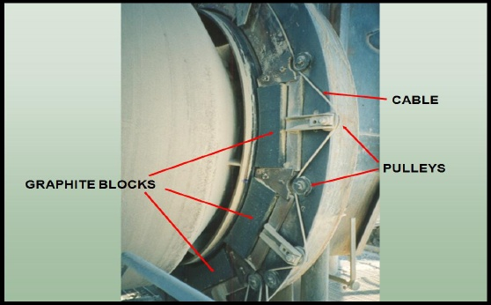
The graphite block seal has been around for many years with several
variation s. the basic components of the seal are two rows of graphite blocks with one end of each block contoured to fit the radius of the shell. The blocks are positioned radially in slide holders that are spring loaded to keep them in contact with the shell.
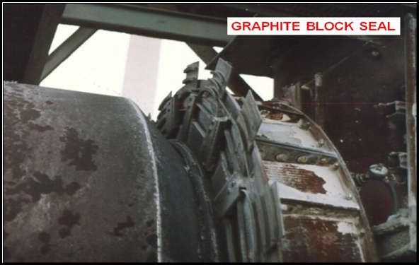
The graphite blocks are staggered in the two rows with every other block overlapping.
Many of these installations have now been converted to some style of leaf seal.
The typical problems encountered with the graphite block seal are heat distortion of the block holders, and dust accumulation causing the blocks to “bind” so they can’t move freely in their respective slides. The result is that the springs can’t keep the blocks in contact with the shell. Another problem is spring failure. Various spring designs have been tried with little success.
The face plate type of seal has many variations, but the operating principle of most of them is the same and therefore the maintenance issues are similar. We will use the arrangement shown in this illustration as an example for general discussion.
The main sealing components are a floating seal plate mounted on the face of the hood, and a fixed seal plate that rotates with the shell. The floating plate has some type of flexible section attached to it which allows the seal to move with the shell. The fixed and floating plates have a wear plate of brass or phenolic material sandwiched between them and held in place with springs, counterweights or air cylinders.
Contamination can cause this type of seal to stick. Typically the floating half gets stuck and the sealing rings will disengage with any axial movement of the shell. Product may also buil up to the point that it deforms the flexible section of the pressure assembly and cause failure.
COMMON PROBLEM causing the face plate seal to leak and become ineffective:
- Failure of the device applying pressure to the seal plates. The device should be inspected regularly.
- The wear plate can become too thin or “ scratched “ and “ gouged” from contamination: the seal will leak.
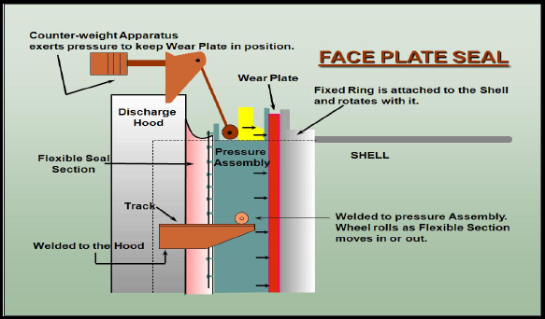
- Excessive run out in the shell. These types of seals are particularly susceptible if the shell run out causes the fixed seal plate to “ wobble”. The flexible assembly will allow longitudinal movement but cannot compensate for “ wobble” of the rotating fixed ring.
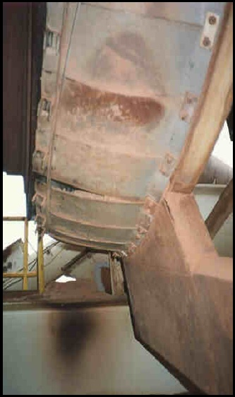
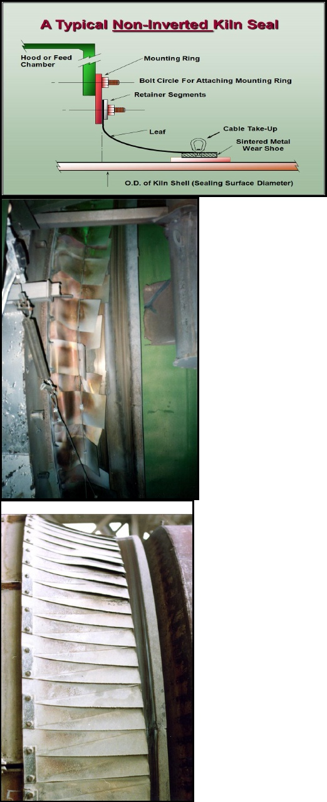
Another common type of seal is the overlapping leaf seal. The two basic designs are outward- facing and inward-facing ( inverted) leaves. The principle of these seals is the same, the major difference being the direction in which the leaves face. The drawback of the outward facing leaves is that they are susceptible to damage from dust accumulation.
Most direct –fired units will operate with a slight negative pressure in the hood on which the seal is mounted. An outward-facing seal acts to seat itself tighter against the shell with that prevailing negative pressure. Hence, it creates a positive seal against infiltration of ambient air which is the seal’s intended purpose. However, most combustion is not altogether “ smooth “ and flame turbulence, even on the best burners, will cause bumps and puffs of positive pressure. The outward-facing seal has an inherent disadvantage because the positive puffs blow the seal open allowing hot air and dust to blow out.
DAMAGE TO NON-INVERTED SEAL
The leaves should be made of a material that can withstand the temperature extremes to which they will be subjected, and still maintain spring pressure without taking a permanent set. The leaf spring should also exhibit some abrasion resistance to provide an adequate service life.
The major drawback of the outward-facing leaf design is their susceptibility to damage from dust accumulation.
7.5 INVERTED SEAL
The spring action of the individual spring plates is strong enough to hold against the negative operating pressure in the firing hood. The first advantage of the inverted seal is that a positive puff will act to tighten up the seal, preventing blow-back. With no blow-back there is no hot air flow, no dust can be conveyed through the seal, and dust accumulation is significantly reduced.
Secondly the seal leaves run on the riding and instead of directly touching the kiln shell. This provides a sacrificial member if wear occurs. The riding band is mounted in such a way to negate shell run –out at the time of installation.
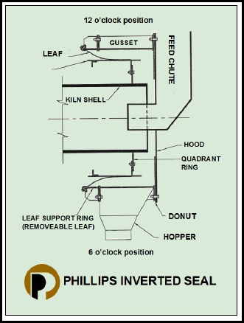
Since the shell run –out will has been all but eliminated the fixing of the seal leaves is minimized thereby extending their service life.
The third advantage of the inverted seal is that at the bottom the seal plates are above a hopper which carries away product spillage. Unlike the non-inverted seal, which “catches” product spillage, the inverted seal does not create a shelf on which product can accumulate. Phillips recommends spraying a graphite powder onto the riding band under the leaves to lubricate them whenever possible. This will help extend their service life.

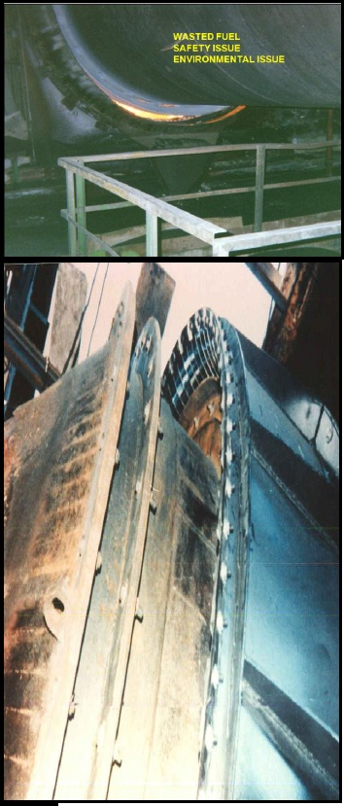
The inverted leaf seal does have a space requirement but the real plus of the inverted seal is its simplicity of design. There are no moving parts to “ stick”. The design incorporates a method to keep the dust buildup away from the sealing components and it is very forgiving of shell run –out.
Operating a kiln or dryer with ineffective seal or no seal costs money in wasted fuel due to ineffective burning. Also, during an upset product can become a major safety issue as well as an environmental problem.

CONCLUSION
In this study project I came to know that while operating the rotary kiln, so many critical condition I seen while doing this project. To maintain the kiln properly in such conditions mechanical plays a vital role in shutdown.
While operating the kiln different parameters to be noted like bearing temperatures, cracks, heat damages, leakages, tire surfaces, vibrations, etc, and these preventive operations is done in shut down. Without doing the correct maintenance some major problems occurred in the kiln which leads to sudden stoppage of kiln.
The frequent stoppages of kiln tends to increase the maintenance cost and decrease the life of the kiln so perfect analysis is to be recorded in the operation and perspective remedies are performed in shutdown.
By effective utilization of the man power and raw materials in repairing the machines will give the excellent results in production rate.

